***The Bible, Prehistory, and Evolution:***

***Toward a New Paradigm***

By Richard Burky

<http://www.earthandlifehistory.org/>

**​**Book 1  Points to Consider

              Table of Contents

               Introduction

               Chapter 1  A Reality Check for Believers and Non-Believers

Book 2  Chapter 2  The evidence for Geologic Time

Book 3​  Chapter 3  The Evidence for Evolution  

Book 4  ​Chapter 4  Two and a Half Million Years of Archaeology 

Book 5  ​Chapter 5  Evolution Is the Product of Intelligence: The Missing Scientific Proof for Natural Selection 

Book 6  Chapter 6  Intelligent, Creative Development: A Viable Paradigm 

Book 7  Chapter 7  A Rationale for Faith Based on the Bible

Book 8  Chapter 8  Evaluating Genesis Chapters 1 to 11

Book 9  Chapter 9  Jesus Was Not a Fundamentalist

Book 10  Chapter 10  The Simple and Profound Story of the Bible (and Bibliography)

**EARTH AND LIFE HISTORY**

Exploring questions of creation, evolution, prehistory, and the Bible



**The scenic Grand Canyon of Northern Arizona.**  Here can be found the beginning chapters of a geologic story that starts one and a half billion years ago and can be traced sequentially upward through time as one moves northward and westward to the latest snow that has fallen in the Sierra Nevada mountains of California.  This area has got to be one of the most profound and fantastic geologic laboratories in the world.

​​**THE QUESTION OF ULTIMATE REALITY**...   IS SOMETHING THAT IS CRITICAL TO EVERY THINKING HUMAN BEING.  THE ANSWER STRUCTURES FAITH, CHARACTER, MORALITY, AND BEHAVIOR.  ONE'S GOALS.AND PURPOSE IN LIFE ARE CONTROLLED BY THE  INTERNALIZED CONCLUSIONS ON THIS QUESTION, NO MATTER HOW CLEARLY OR HOW POORLY THEY HAVE BEEN REASONED.

**Chapter 1  A Reality Check for Believers and Non-Believers**  
.The mystery or reality for humans is that we are here and we cannot physically or conceptually prove how we got here.  A fantastically great and expansive universe is here and we cannot physically prove how it got here.  How does something come from nothing?  Or, how does something exist without ever coming into being?  This conundrum also applies to God.  How could such a being come into existence.  Or how could He have always existed?   I believe these concepts are beyond comprehension by our human minds.  But the fact remains that we are here and the universe is here.  We must work with these facts even though we cannot conceive origins.  
  
Certainly we can determine much about the earth’s past from the records of geology, paleontology, and the archaeology.  Likewise we can understand much about the content of the universe, its size, structure, and past history.  But the base question of where this all came from or how it got here is humanly and physically unanswerable.  What mathematical formula reveals how something can come from nothing?  If we cannot answer where or how, is it little wonder then that we can’t answer the even more meaningful questions of why and for what purpose?  How should we be living our lives?  
  
It is simply impossible for humans to physically answer these questions.  Functional answers to these questions are sought through faith and philosophy.  These answers allow us to get on with life and the business at hand.  However, we often accept the faith and philosophy by which we live without much critical thought.  We may follow the religion of our parents and family.  We may pick up a philosophy in high school or college that seems to accepted by the majority and adopt it as our own.  Our culture often overwhelms and dominates us.  Proving one philosophy or faith wrong doesn’t guarantee that the replacing philosophy is correct.  
  
The scientific method is a wonderful and powerful tool we humans have discovered and used extensively.  It has given us the power to transform our lives and even the planet on which we live …for the better and for the worse.  Using that tool might show us that we have some answers to the big question that are wrong because they don’t fit reality, but as a tool it cannot provide the answer to the big question either.  It is the wrong tool for the job.  Science is a materialistic tool for working with materialistic processes.  It does not solve metaphysical problems.  
  
Another of the big questions for humanity: Is there something beyond the physical, material world?  Is there something beyond the natural or is this all there is?  Is there a supernatural essence or realm?  Since science deals only with material it is unable to answer this question.  
  
To one of materialist philosophy this may seem a foolish question.  It’s thinking outside the science box.  The materialist considers that only those things detectable by physical means are a reality.  But is this true?  
  
Certainly scientists can break matter down into smaller and smaller units, but what is a quark really?  What is it made of?  Is it a particle of something?  Is it energy?  Is it some type of “force field?”  Or is it made up of something we might call a “supernatural” essence, whatever that may be?  
  
Light can travel at incredible speeds for millions, indeed billions, of years without slowing down or needing an energy boost.  How can it do this?  What is the substance of light, really?  We could ask the same question of gravity, magnetic forces, and nuclear binding forces.  Even these “natural” physical things seem to disappear into the unnatural or “supernatural.”  Will we find that physical and “spiritual” are really somehow connected entities?  
  
But for the present, we cannot use scientific methodology to prove or disprove the existence of the supernatural.  An atheist cannot prove his conclusion that God does not exist by science.  Nor can the believer scientifically prove that God really does exist.  If we depend upon physical means alone we are left without an answer and may become agnostics, believing that the question cannot be answered.   But this is a conclusion based on faith as well.  Indeed, believers, agnostics, and atheists all base their philosophy on faith.  
  
I believe we were “intelligently designed,” but I believe it is a misguided approach to attempt to prove that by scientific methods.  Scientific methodology is the wrong tool to use.  I don’t believe a decisive conclusion can ever be made by such methods.  But we should certainly use science and the scientifically determined facts to help evaluate the matter.  It is critical that we understand the difference.  
  
Faith is a necessary component of human life precisely because we cannot prove everything scientifically.  It is as if it were designed or set up to be so.  Life’s decisions have to be based upon something.  Faith is very useful, I would say necessary, to fulfill that purpose.  It gives us a base from which to work and move beyond debilitating uncertainty.  It promotes a healthy human mind and spirit.  Faith is common to the believer, the agnostic, and the atheist.  It fills the gap that science cannot fill.  Faith is a good thing.  
  
Although faith is often emotionally or culturally derived, such derivation would seem to be the poorest basis for faith.  I believe faith, while it is not scientifically provable, should be a decision, or a conclusion that is based on the best possible information available.  That would include not only information from science, but also information from other sources of human experience.  The conclusion certainly should be logical and reasonable, not illogical and unreasonable.  Better information should yield a more sound and reasonable faith.   
  
All faiths have not been created equally!  One purpose of this book is to encourage a sounder faith.  One that is most apt to be true.  For this, the best and truest information must be used.  
  
When analyzing a faith based on the Bible, it is absolutely necessary to see that faith in relation to what can be known about the prehistoric record and the physical world.  Rejecting or ignoring what is scientifically knowable about the prehistoric time period can only lead one to error in faith.  For this reason it is critical to take a brief look at the record of that time period and the procession of life forms that have lived throughout it.  Many believers, in their faith, are compromising with the truth of the prehistoric record and don’t even realize the extent of that compromise.  
  
Such a brief overview of prehistory will be examined in the next chapters.  The picture presented is correct in overall structure but certainly not complete in any way.  Many other authors give encyclopedic coverage to the topics covered that is much more thorough and complete.  What I strive to present in these chapters is the rational basis for knowing and believing those things that most impact a biblical faith from the prehistoric record.  The two chief concerns are the great length of time involved and the development or “evolution” of life forms during it.  These cause the believer the most question and concern.  
  
The author has very little contention about the facts that are known about prehistoric time.  I have had extensive academic training in that area (many geology and paleontology courses, plus a PhD. in archaeology with research on radiocarbon dating bone) and have done extensive field work to verify that academic training.  The big issue is the paradigm and philosophy, both based on what I would term faith, into which those facts are traditionally placed.  It is this issue and the search for a new paradigm upon which this book is based.  Since many religious people contest the facts of prehistory, it is necessary to verify that they really are true for the development of a valid paradigm.  Holding to a faith that contradicts the known and verifiable scientific facts is a foolish decision.  Faith is a decision.  It should be based on the soundest information possible.  
  
The real issues are philosophy and paradigm not the scientific realities.  However, contenders on both sides of the argument are convinced they are holding to the facts.  My conclusion is that generally believers don’t really know the facts or alter them to fit their faith, while the materialists overstate the case of what the facts actually prove beyond any reasonable doubt.  Both actually manipulate facts to fit their paradigm.  I will attempt to not do that.  
  
As a human being I cannot fully understand why I am here or why anything is here.  Our existence is a great mystery that can only be answered with faith.  But we need the faith that best fits the facts, scientific and other, that we can know.

**Introduction**  
  
When faith or belief becomes more important than truth, there is a problem.  
  
In the last 150 years the Bible and the God revealed in it have taken a severe, many would say fatal, hit.  Is it really time to dump the Bible as a reasonable source of belief and faith about the true meaning of life?  This author thinks not.  The Bible has been given unreasonable condemnation by many of its critics and unreasonable support by many of its proponents.  Erroneous or poorly reasoned support is no support at all!  
  
Some biblical defenders have trashed much of the factual scientific data from geology, paleontology, and archaeology so they could maintain an obsolete understanding of the Bible.  In their desire to support the Bible by such means they actually discredit it.   Opponents have seized upon these obsolete and faulty conclusions to further attack the Bible as a source of meaningful faith.  One must evaluate and understand the Bible in the light of the scientific knowledge of prehistory.  Such an approach to understanding the Bible is being proposed in this book.   
  
Science is a very effective materialistic tool for exploring the materialistic world.  It is a weak and ineffective  tool for discovering, understanding, or defining a spiritual or metaphysical world.  While science can give us factual material which we must consider as we make our decisions on questions of faith, it can neither confirm nor deny the non-materialistic, supernatural world described in the Bible.  The biblical narratives and descriptions are based on human experience and eye witness accounts which are not a part of scientific methodology, but are not falsifiable by science either.  
  
Science is materialistic by nature but it is not materialism.  Materialism is philosophic by nature and not scientifically provable.  It is necessary to understand the difference.  
  
There is a legitimate need for humans to think and make judgments outside the science box which is limited to materialistic tools.  Many judgments and decisions in life have to be made without the control of scientific methodology.   Such judgments and decisions should, however, be made rationally and logically.  They should not be conclusions that are contrary to scientifically proven data. Human faith is one such decision. The reality of life is that everything cannot be scientifically tested and proven or disproven.  We have to draw conclusions and make decisions based upon the best information available to us.  Religious faith is one such decision.  
  
Faith can’t wait for all the facts to be in.  Life is not long enough.  A decision has to be made on the best facts available, even if partial, and the faith modified as more facts become available.  
  
Most fundamentalist Christians argue about the wrong things… Geologic time …Evolution …Missing links …Or insist upon an absolute literal interpretation of the early chapters of the Bible as though it fell directly down from heaven intact, translated into English.  “God said it.  I believe it.  That settles it.”  
  
Most materialistic critics of the Bible really don’t understand the Bible either.  Their criticism is often based on the behavior of religious people, a shallow, incomplete understanding of the Bible, or the theological and cultural encrustations and interpretations that have been read into and added to the Bible over the years by many religious individuals and groups.  Concepts like humans possessing an immortal soul, a never ending punishing of bad humans in hell fire, and good humans going to heaven upon death.  These, and many other concepts, have been read into the Bible, not out of it.  The biblical story is quite different than most, even Christians, realize.  
  
If religious people do not bring their understanding of the Bible into alignment with solidly supported scientific truth and reality they will pass on to their children and others a flawed faith.  They are setting them up for failure of faith when the truth becomes clear.  Changing one’s faith to correspond to truth is certainly a proactive and necessary endeavor.  Why would anyone do anything else?  
  
A Note on the Author’s Biblical Interpretation  
  
How we view and interpret the Bible is critically important to what we take from it.  
  
A primary question to ask is…  Do we evaluate it as one whole book in which every individual “book” has the same evaluation of literalness and veracity?  Or do we see it as a compilation of many works and “books,” written and edited over a wide range of time by many authors from various cultural backgrounds, to which a varying degree of literalness should be applied?  The author favors the later.  
  
Does one method of evaluation apply equally to every part of the Bible?  I think not.  Differing means of judging apply to different books.  The Song of Solomon is certainly to be evaluated differently than the law of Moses in Deuteronomy.  The book of Ecclesiastes is a decidedly different book to be understood in its own way.  
  
For example, can we question the origin, source, and literalness of certain Genesis 1-11 writings and still conclude that the laws given to ancient Israel are inspired and to be guiding principles for us even today?   Can we question the literalness of the two creation accounts in Genesis 1 and 2; the literalness of a totally worldwide flood, which would seem to be implied in Genesis 6-9; or the literalness of the multiple hundred year lifetimes of individuals reported in Genesis 5-11; while still upholding the uniform moral principles which start in the Pentateuch and continue to the end of the New Testament?  I believe the answer to all of these questions is yes.  
  
I believe a serious mistake is made when the whole Bible is considered to be wholly and perfectly inspired word by word by God.  This is not how Jesus dealt with the Scriptures.  He made corrections.  He did not change the basic law and principles of God which He said would not change until heaven and earth pass away.  He did, however, correct principles given in the Scriptures that were not fully compatible with those eternal principles of God.  Details of this are found in Chapter 9.  
  
I believe the Bible is best seen as a sequential, expanding view and revelation of the Creator, his nature, character, and purpose for humankind.  It can be seen as a step by step development of God revealing Himself and his purpose to human beings.  …First as the Creator, then through many steps to a more complete understanding of His character and purpose by the end of the New Testament.  
  
This is not a “pick and choose what you want to believe” approach to the Bible.  It is rather an honest seeking to understand the ultimate, most complete message and meaning of the Bible.  Truth from all sources should be taken into account.  That includes geology, paleontology, and archaeology.  Any question is more easily answered by disregarding or discarding half of the evidence.  But this is not the kind of answers we are seeking.  
  
Can we allow the Bible to be a humanly written history of human interaction with the Creator God over a period of about two thousand years?  This does not take away from the inspiration of the laws and principles that were given by that Creator, but it would explain the minor inconsistencies and problems we find in the text.  Such an interpretation in no way condones the neglect or rejection of the laws and principles that were given by that Creator.  Interpreting the Bible in this way does not negate the possibility of direct, word by word inspiration of portions of the Bible but allows much of it to be otherwise.  
  
It is interesting that Jesus, though literate, left no known written records of His own.  He left it to others to write down what He taught.  Why He did so seems worth considering.  
  
If we insist that the whole Bible is divinely inspired word by word in a literal way we discredit it when problems are found in the text that contradict such a reality.  Why would we interpret the Bible in such a way as to set it against what is true?  This may be seen by some as a “slippery slope” approach to understanding the Bible but I believe it gives a truer picture of the biblical reality.  Certainly truth, not dogmatism, is what we are seeking.  
  
Canonization of the biblical writings brought together those writings that are judged to most accurately describe God and his ways.  By faith we believe God has had a part in guiding this process.  This is not a blind faith.  The Bible, seen as a whole, presents a unified context and viable picture of reality that rings true.  A unified code of morality runs throughout the Bible from Genesis to Revelation.  This conclusion is presented in more detail in chapter 10.  
  
On a personal note...  I started my adult life pretty much as a biblical fundamentalist with a sincere concern about the evidence from geology, paleontology, and archaeology.  After years of studying these fields, academically, personally, and professionally, truth has forced me to abandon the fundamentalist approach.  While I have an undergraduate degree in theology, most of my academic training has been in science.  I have completed considerable college course work and field work in both geology and paleontology.  I obtained a PhD. in anthropology with a concentration in archaeology from the University of California.  My dissertation research was on radiocarbon dating fossil bone.  The conclusions of that research were published in the professional journal, Radiocarbon.  Additional discoveries made during that research were published as a chapter in the book, Perspectives in Amino Acid and Protein Geochemistry published by Oxford University Press.  I currently teach in the California State University system.  
  
I remain a committed believer and Christian, holding the Bible and its moral teachings in the greatest respect.  I see it as a written account of human interaction with the intelligent Creator over a long period of time.  I do, however, understand it from a substantially different perspective than that of the typical fundamentalist and/or modern Christian.  It is this new paradigm for eliminating the apparent contradictions between scientific data and the Bible that I am exploring in this book.  It retains the concept of an intelligent Creator in our thinking while accepting the latest scientific knowledge. Certainly there will be much to add on the subject as study proceeds.  
  
                                                       Richard R. Burky, PhD.  
                                                       Altadena, CA  
                                                       August   2014

***​​The Bible, Prehistory,and Evolution: Toward a New Paradigm***  
  
  
**Concepts to Consider:**  
  
Faith is a necessary component of life for all individuals to function effectively with issues and questions that cannot be materialistically proven.

**Chapter 2  The Evidence for Geologic Time**



**Figure 2.1.**  The Grand Canyon of the Colorado River in Northern Arizona.  It reveals 1.5 billion year old crystalline and metamorphic rocks at its bottom which are overlain by horizontal geologic strata the youngest of which is about 250 million years old.  The strata seen in the picture were all deposited before the dinosaurs ever walked the earth.  But this is only the beginning of the Colorado Plateau strata record.

**Geologic Sequence and Time**  
  
Merely looking at a landscape anywhere in the world doesn’t necessarily give one a realistic feel for the depth of the geologic time.  There are many areas of the world where one would be completely oblivious to the fact that there was such a time depth in geologic history.  However, standing on the rim of the Grand Canyon in Northern Arizona is not one of those places.  One can begin to get a truer view of the history of the earth here.  But even this view is only the tip of the iceberg as far as geologic time.  It is an introduction to perhaps one of the best places in the world to explore the reality of the geologic record.   
  
The geologic history in this area is outstanding for its completeness and ease of observation.  The Grand Canyon is located on the southern portion an area known as the Colorado Plateau.  The geologic strata over this approximately 160,000 square miles area are like a giant layer cake.  (The area covered by the Colorado Plateau is illustrated in **Figure 2.2**).  The strata layer cake has been somewhat bent and folded in areas but the layers are still remarkably easy to trace for many miles.   
  
  
​Many National Parks and National Monuments in the Colorado Plateau preserve and allow observation of these strata.  The individual layers, or more precisely formations, vary in thickness from a few hundred feet to over a mile in places.  This is no small layer cake!

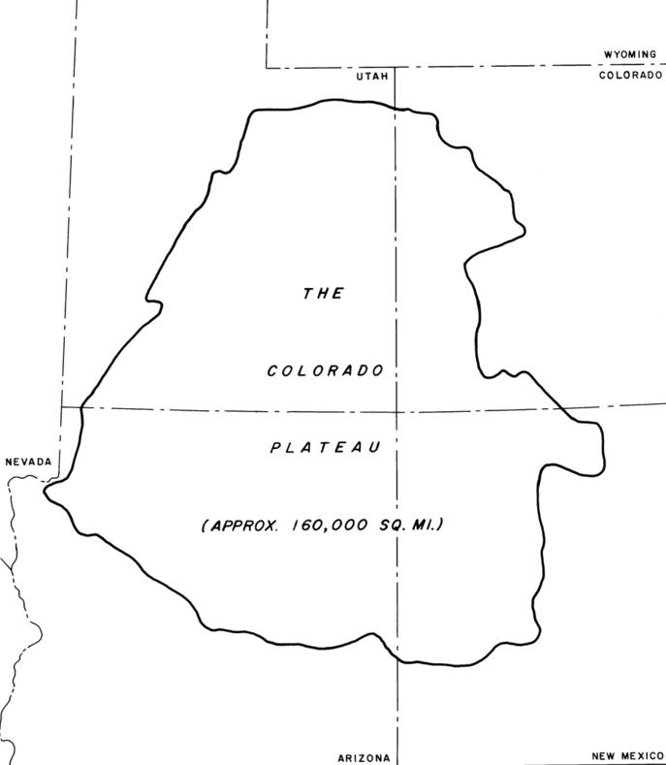

**Figure 2.2.**The Colorado Plateau covers large areas of four states.   Its strata reveal a rich depositional history that encompasses all of the world’s four major geologic time periods.  Much of this area is steppe and near desert climate with scant vegetation cover.  This allows the geologic strata to be clearly seen.  It is without doubt one of the finest areas in the world to show the true nature of the geologic record.

An overview of the geologic strata is presented in **Figure 2.3**.  **Figure 2.4** illustrates how the strata shown in**Figure 2.3** represent the geologic time periods.  To understand the cross section pictured, think of a giant layer cake being sliced in half.  In this case the strata “layer cake” is being cut from Northern Arizona south of the Grand Canyon all the way across central Utah to the Wyoming border.  What is pictured is a cross section of the strata that are found from South to North.  
  
The strata represent a wide variety of sedimentary depositional environments.  These include lakes, rivers, oceans, mudflats, deserts, evaporation basins, forests, lava fields, etc.  They represent deposition and other geologic activity during all of the world’s four major geologic time periods: Precambrian, Paleozoic, Mesozoic, and Cenozoic.  It is unique to have so much of geologic time represented by geologic activity in such a localized area.  This is an ideal place to begin to understand the true nature of the geologic record.

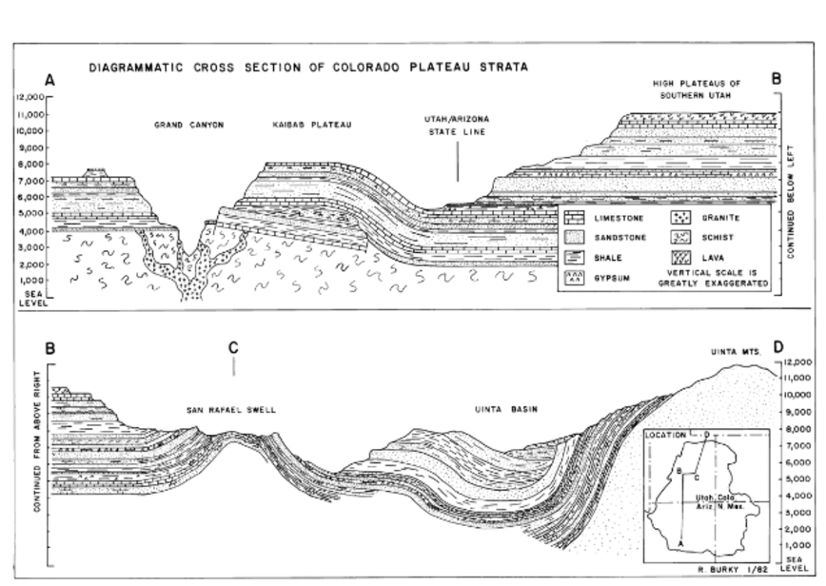

**Figure 2.3.**A cross section of the strata of the Colorado Plateau.  The vertical dimension is greatly exaggerated to give a better illustration of the strata and their relationships.

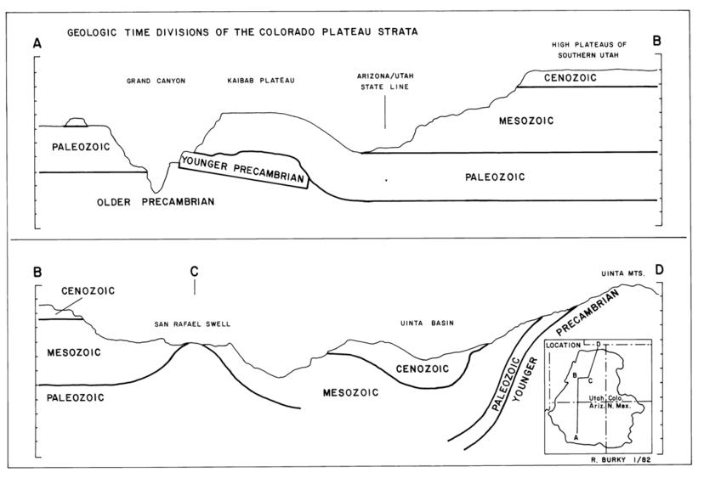

**Figure 2.4.**The geologic time periods represented by the strata of the Colorado Plateau.  The time periods of deposition of these strata can be compared to the geologic time scale that has been developed for the whole world, shown in **Figure 2.5**.

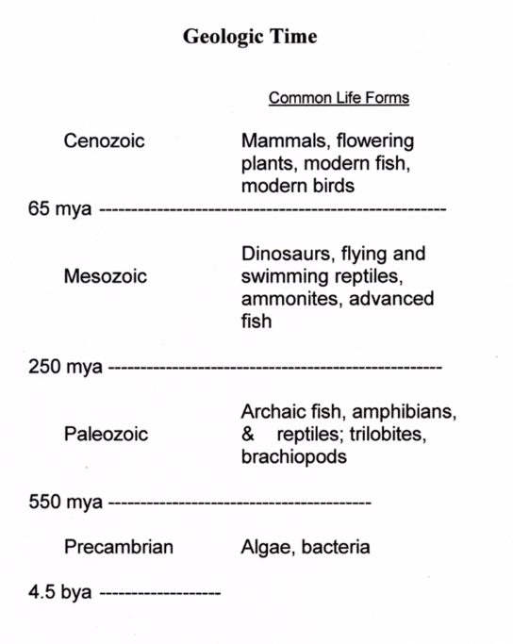

**Figure 2.5.**The generalized geologic time scale.  This is a time scale that outlines all geologic strata and events for the whole earth.  The life forms listed are only a few of the more well known ones that were dominant during, or unique to, the period.  Certainly it is a very incomplete listing of all the animals that were living at any given time.  (mya = millions of years ago, bya = billions of years ago).

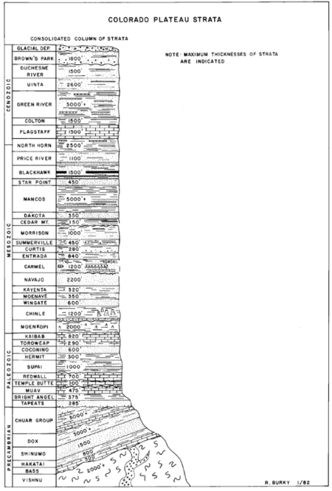

**Figure 2.6.**A composite of the formations shown in **Figures 2.3 and 2.4** with their formation names, approximate greatest thickness, and the time sequence in which they were deposited.

**Figure 2-7.**The bottom of the Coconino Sandstone.  The windblown sand has been deposited on mud, silt and sand that was deposited by water.  The difference is striking even though the cross bedded pattern of the Coconino doesn’t show up well in this photograph.

**Fossil Deserts**  
  
Perhaps the easiest and most obvious way to evaluate the geologic record is to examine the materials of the strata themselves.  This often gives clear evidence to the method by which they were formed. In the layer cake of strata we are examining there are three fossil deserts lying in superposition, one on top of the other, with significant intervening water deposited strata in between (**Figure 2.6**).  The lowest desert is the Coconino Sandstone, next the Wingate Sandstone, and then the biggest fossil desert known in the world, the Navajo Sandstone.  This desert can be traced from west of Las Vegas, Nevada, across all of Utah, and into Wyoming.  Some of its maximum thicknesses occur in the area of Zion National Park.  There its sands were piled up to over 2,000 feet thick.  This formation forms the spectacular cliffs of the park.  
  
How do we know these were deserts?  …By the nature of the deposition and the materials deposited.  The material is clean sand grains that have been winnowed and sorted by size, then deposited in dune structures typical of wind deposition.  They contain massive cross bedded structures typical of sand dunes.  Materials deposited in water show a significantly different structure and the grains are not nearly so well sorted by size.  This difference can be readily seen by examining adjacent strata that were deposited by or in water.  See **Figures 2.7 and 2.8**.  **Figure 2.9** shows a good example of the dramatic cross bedded pattern of wind deposited sand.



**Chapter 3       The Evidence for the Evolution**  
  
A clear truth from the geologic record is that both animals and even the human form have changed through a developmental process over long periods of time.  Few animals appear in their modern form at the time when they are first found as fossils.  Most change substantially from their first appearance to their later forms. Animals that are exceptions to this general situation have been given the name “living fossils.”   Well known examples are dragon flies, cockroaches, horseshoe crabs, and the coelacanth.  There are many others that are less well known.  These animals have remained without substantial change for multiple millions of years.  But these unchanging forms are more the exception than the general rule.  Animals usually change through time.  This change has come to be called “evolution.”  That such change has actually occurred is scientifically provable.  From this definition and perspective, “science does prove evolution.”   This chapter presents some of the evidence for such change in four lines of living mammals.  
  
What science doesn’t really prove is how these changes have been produced.   Many materialists were thrilled when Charles Darwin and Alfred Wallace developed the concept of natural selection as a natural process that can produce change in animals over time.  Certainly natural selection can and does make changes in the genetic material of living organisms.  That is simply how the physical genetic system works.  However, this doesn’t prove how the fantastic genetic system originated or how the actual changes were made in the lines of individual organisms.  Neither does it prove how major changes in fossil lines of organisms have changed so dramatically in such short time periods.  Random mutation and natural selection are assumed to be the causes when one artificially limits the logic to only known natural processes.  This allows the problem to be kept within the definition of science.  What if one logically thinks outside the science box?  
  
Selective breeding by human intelligence can produce changes in organisms even faster and that are more dramatic.  Darwin was fascinated by the change in pigeons that such “artificial” selection could make.  Consider how long the wolf remained a wolf under natural selection pressures.  This is in contrast to the many varieties of dogs that were created in a much shorter time by artificial selection directed by human intelligence.  What will happen when humans begin to actually replace or modify the chemical structure of a dog’s genes?  There does seem to be a limit to the extent of change that the natural genetic material will allow such artificial selection to make in organisms.  This should cause one to consider the limits that natural selection can make in animals.  
  
Did natural selection create the organism?  Did it create the complex genetic system?  This author believes that proving natural selection made the major changes in the fossil animal lines is not even open to valid scientific evaluation.  It would seem that it can neither be proven nor disproven by available scientific methodology.  Scientific proof requires repeatability.   The environment cannot be set up and the experiment re-run.  Both time and complexity are against this.  The conclusion is really a philosophical or theoretical one.  This topic and issue are dealt with more fully in other chapters.  
  
The purpose of this chapter is to show that great changes have indeed occurred over long periods of time in the fossil lines of many animals.  Three well known animal lines, and the vitally important human line, have been selected to give specific examples of what changes have occurred through time.  Such proven changes over time must be taken into consideration whether one concludes that natural or supernatural forces were the cause.   The animal lines that will be examined are the horses, elephants, and camels.  The cause of those changes are discussed in chapters 5 and 6..  
  
A religious person may wish to hide from this knowledge and pretend it doesn’t exist.  He or she may vehemently deny it, but the clear evidence remains.  If one is honest with facts and patient enough to spend the time looking, the evidence is there.  A lot of it!  What is presented only scratches the surface.  
  
These facts must be taken into account when we consider the paradigm by which we understand and interpret the Bible.  Not knowing or ignoring the truth does not help.  For an understanding of the Bible to be creditable it must accommodate these realities.  If we choose to interpret the Bible through the typical fundamentalist paradigm we do irreparable damage to the credibility of the Bible and ultimately to a biblically based faith.  
  
The mechanism of evolution, however, may not be what most materialists would have us believe.   An interesting fact to consider is that evolution is a process and function of intelligence.  We live with evolution every day.  Society and culture evolve.  Our languages are evolving continually.  Nearly every human invention and technology evolves.  Automobiles evolve.  Airplanes evolve.  Computers evolve.  Even simple bottle and can closures have evolved.  Is there any technology that doesn’t evolve?  This evolution occurs as a product of creative human intelligence.  The end result is not seen from the beginning.  The current product is what has been developed over time and it continues to change.   
  
Is the evolution of the “natural” world any different?  The Bible reveals an overseeing, creating intelligence which is generally referred to as “God.”  The Bible states that man was created in this God’s image.  Why would one assume the Creator is not a creative thinker?  Does that Creator develop and change things through time?  Why would one conclude otherwise, especially when there is such an abundance of physical evidence for so much change and development in the physical record?  This doesn’t mean that natural selection doesn’t work or make some changes.  It seems obvious that it does.  However, to this author, other changes seem way beyond the reach of mere natural selection.  It seems a better conclusion that an Intelligence was actively guiding the overall process.  By “better” is meant “more apt to be true.”  
  
If we believe that God is responsible for the creation of the earth wouldn’t it make sense to get the very best information on what is really in the physical record to understand how it was done?  Does it make sense to argue with the scientists who spend their lives learning about geology, paleontology, and archaeology, that their facts are wrong?  Certainly most scientists are putting their facts together in a paradigm with which the believer, including the author, would disagree.  While we need to agree on facts that are true, we need not accept the philosophical paradigm.  This is especially true if we have a paradigm that fits those facts even better; which this author believes we do.  
  
Let’s first take a brief look at the fossil evidence for the evolution of these three lines of living mammals and then at the fossil evidence for that of human beings, who are also, by accepted biological definition, mammals.   
  
**The Horses**  
  
The evolution of the horse is the classic story of animal evolution.  It is one of the first known and best documented of the evolutionary lines.  Its development spans a time period of over 50 million years.  Figure 3.1 is a chart that illustrates when various genera of fossil horses lived in prehistoric time.  Note that the chart covers only the last major geologic time period, the Cenozoic with its subdivisions.  It is during this time period that all horse fossils and most other mammal fossils are found.  For this reason, and to simplify and correlate the understanding of these different lines, the same chart and chronological framework is used for all four lines.   
  
The reader is referred to chapter 2 for questions about the validity of the known geologic record and time scale.

* [**HOME**](http://www.earthandlifehistory.org/home.html)
* [**ARTICLES**](http://www.earthandlifehistory.org/articles.html)
* [**BOOK 1**](http://www.earthandlifehistory.org/book-1.html)
* [**BOOK 2**](http://www.earthandlifehistory.org/book-2.html)
* [**BOOK 3**](http://www.earthandlifehistory.org/book-3.html)
* [**BOOK 4**](http://www.earthandlifehistory.org/book-4.html)
* [**BOOK 5**](http://www.earthandlifehistory.org/book-5.html)
* [**BOOK 6**](http://www.earthandlifehistory.org/book-6.html)
* [**BOOK 7**](http://www.earthandlifehistory.org/book-7.html)
* [**BOOK 8**](http://www.earthandlifehistory.org/book-8.html)
* [**BOOK 9**](http://www.earthandlifehistory.org/book-9.html)
* [**BOOK 10**](http://www.earthandlifehistory.org/book-102.html)
* [**CONTACT**](http://www.earthandlifehistory.org/contact.html)

**EARTH AND LIFE HISTORY**

Exploring questions of creation, evolution, prehistory, and the Bible

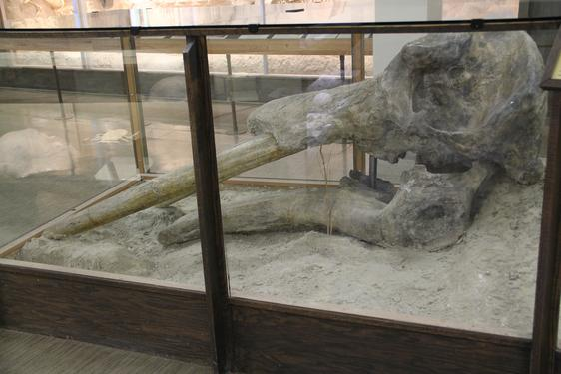

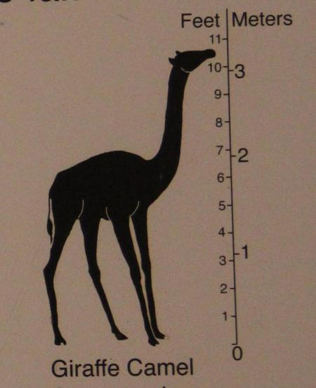



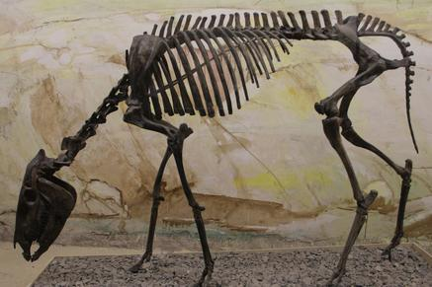

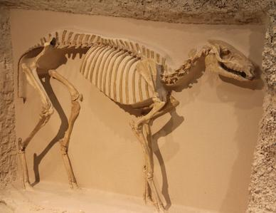

**Summary of The Hominins**  
  
This brief pictorial overview of the history of the hominins illustrates the change in the human form throughout the past four million years or so.  Certainly infinitely more detail could be presented but this overview should be adequate to show that development or evolution of the human form has occurred over this extensive time period.  The real cause of these changes is the key question in relation to faith.  This is dealt with in other chapters of the book. The fact that significant changes have occurred should be beyond question.  
  
**A Summary Statement on the Evidence for Evolution**  
  
We have examined the fossil evidence of four lines of living mammals.  The purpose for doing this is to give an overview or summary of the reality of evolution, or development over time, in the fossil record.  These four lines are not unique.  Nearly every line of living organism for which there is an adequate fossil record shows similar patterns of change through geologic time.  This is the reality of the fossil record.  
  
A fundamentalist may ignore this record but the reality of the record remains.  When evaluating religious faith …truth matters.  For the individual who uses the Bible as the source of religious faith these realities must be taken into account when considering how to understand the Bible.  The purpose of this book is to explore how to best understand the Bible in a way that takes these realities into account to give a truer picture of the past and a sounder hope for the future.

**Figure 3.58***Homo sapiens*. The general form of the modern skull is found as a fossil as old as 150,000 or more years ago.  The culture associated with skulls of the earliest age indicate a much lower level of intelligence and creativity than that associated with later Homo sapiens (Klein and Edgar 2002). 





***Homo habilis***  
  
Estimated age: 1.6 to 2.0 mya  
Estimated brain size: 630 cc  
Brow ridges: Prominent  
Prognathism: Prominent  
Comments: This species is subject to considerable variation and interpretations.  One similar species is *Homo rudolfensis* (KNM-ER 1470).  
  
 .



**Figure 3.52***Paranthropus boisei*.  (Leaky’s  *Zinjanthropus*)  (Source of cast unknown.)





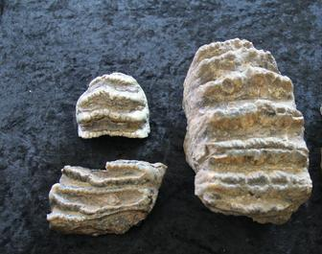

**Figure 3.40***Stegodon*  teeth.  Side view and occlusal view.  These teeth are low crowned but of  somewhat similar design to those of the mammoths and modern elephants.

**Figure 3.34***Mammut* (The Warren Mastodon)  Mastodons are significantly different than the gomphotheres and the mammoths.  Note the difference in the teeth.  These are low crowned teeth and completely different in construction than those of the gomphotheres, mammoths or modern elephants.  Compare with**Figures 3.35, 3.33, and 3.38.**



**Figure 3.33**A few typical Gomphothere teeth.

**Figure 3.32***Stegomastodon* a very late member of the Gomphothere Group from North America.  Note the very long tusks and the very short lower jaw.  Yet it still had "Gomphothere" teeth.  (Univ. of Nebraska State Museum).



**Figure 3.28**Classified with the Gomphothere Group, *Palaeomastodon* one of the earliest of the fossil elephants..  This model of the skull is in the Prague Museum of Natural History.  Note that it has tusks on both the upper and lower jaws.  This is not uncommon for many of the Gomphotheres.

**Figure 3.20** Above are two mandibles from different genera of modern camels.  The bottom mandible is of the genus, *Camelus*.  The top is of the genus, *Lama*.  Note that the size is considerably different but the structure of the teeth and jaw is very much the same.  These features together with their similar two toed foot bones make it easy to see why they are both considered to be camels.



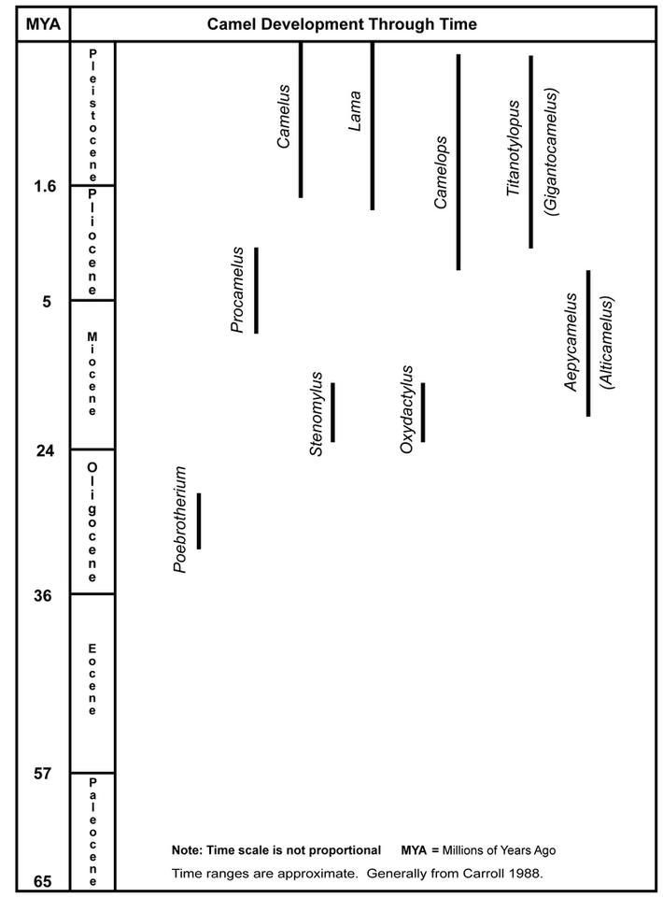

**The Camels**  
  
Camels have a 30+ million year fossil history.  Most of that history is found in North America.  Only in comparatively recent geologic time have camels made their way into Asia, the Middle East, and North Africa where we think of them today.  Modern living camels include the two-humped Bactrian camel of Asia and the one-humped dromedary of the Middle East and North Africa.  They are often both included in the single genus Camelus.   Earlier in geologic time camels made their way from North America into South America and survive there today as the genus Lama, into which the llamas, alpacas, guanacos, and sometimes vicunas are placed.  Some authors place vicunas in a separate genus, Vicugna.

**Figure 3:16** shows the camel genera in relation to when they are found as fossils in the geologic strata of the Cenozoic time period.  This is the same graphic framework that was used for the horses.

**Figure 3.14**A sequence of the structure of the front feet of horses from *Hyracotherium*,*Mesohippus*, *Parahippus*, *Merychippus*, and *Equus*.  Hyracotherium had four toes on the front feet and three on the rear.  The now extinct Hipparion Group continued the three-toed condition throughout their existence.

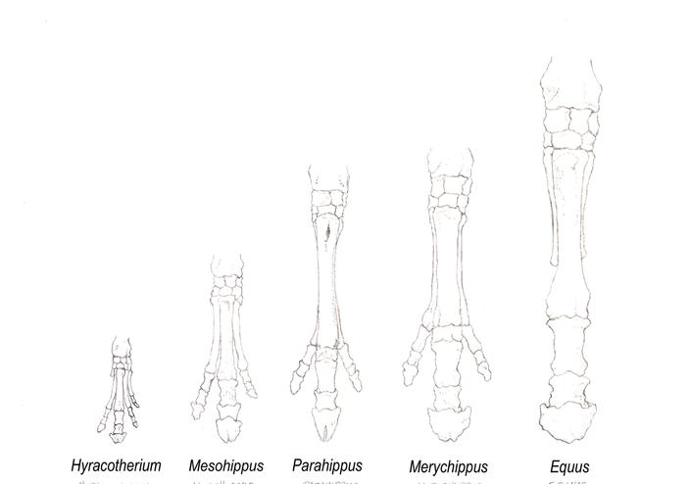

**Figure 3.13**The occlusal surface of an *Equus* tooth showing how the cones and lophs relate to those of *Mesohippus* shown in **Figure 3.8**  Since this is a heavily abraded surface the cone peaks have been worn off as have the enamel ridges of the lophs.  The new material cementum has been added outside the enamel to strengthen the tooth.  It makes the cones and lophs a bit harder to distinguish.

**Figure 3.56***Homo heidelbergensis*. (Broken Hill, Kabwe, “Rhodesian Man”) (BONE CLONES® BH-004.) 



***Homo heidelbergensis***  
  
Estimated age: 500,000 to 200,000 (?) ya  
Estimated average brain size: 1,200  cc  
Brow ridges: Very prominent  
Prognathism: Prominent  
Comments: Sometimes called “Archaic (or Early) *Homo sapiens*.”  Some even consider it a continuation of*Homo erectus*.

**Figure 3.55***Homo erectus*. (Source of cast unknown.)

**Figure 3.50***Australopithecus afarensis* (A.L. 288-1”Lucy”).  (BONE CLONES® BH-021-A.)



***Australopithecus afarensis***  
  
Age: 2.9 to 3.9 mya  
Estimated average brain size: 420 cc  (About that of a chimpanzee)  
Estimated height: 3 ft 3 in to 5 ft 7 in  
Brow ridges: Very prominent  
Prognathism: Very prominent

Comments: While “Lucy” is the most famous, more complete skulls of this species have been found..

**Figure 3.49***Ardipithecus ramidus*.  (BONE CLONES® BH-039.)

Stegodon (Waiting for graphics.)

***Stegodon***

In many ways the differences between the genera in the camel group through time seem rather limited in relation to the changes seen in the horses and elephants.  Their tooth and foot design stayed remarkably similar throughout their history.  Most important  is that camels are another group that has been around for multiple millions of years.  During that time they changed enough to be grouped into discrete separate groups or genera that shared common characteristics within the group in addition to the common characteristics shared by all other “camels.”  
  
  
   
**The *Proboscidea* (The “Elephants”)**The elephant-like animals are another interesting group of mammals that show substantial variety and change, especially in their skulls, teeth, and tusks, through time.  Consider the history outlined in **Figure 3.27**.  The earliest obvious “elephant” in the line is Palaeomastodon from North Africa.   The only two living genera of elephants are Elephas, the Indian elephant, and Loxodonta, the African elephant.  The time in between the beginning and end of the line is filled with an unbelievable variety of elephant forms, most will not even be mentioned in this chapter.  **Figures 3:28-44** will help give a feel of some of these different forms.  (For more detailed information on elephant development see….Osborn  1936 & 1942. Maglio 1973, Shoshani and Tassy 1996, Lambert and Shoshani 1998.)  
  
That there is substantial change in the elephants throughout the second half of the Cenozoic is without question.  What really caused those changes remains the major question.  
  
It is nearly impossible to present a reasonably complete picture of the history of the elephants.  At best there are more holes in the picture of their history than in that of the horses.  The important thing to realize is that there were many different types of elephants living over many millions of years.  Many of these were very different from one another in skull, tooth, and tusk.  
  
If Deinotherium is used as an example we find a head scratching situation.  In form and size it is much like an elephant.  It lived on earth for a long, long time with really very little change in its basic form.  From the early Miocene until the times of the hominins which we will discuss later in this chapter.  Its general form stayed very similar throughout that time span, unlike many of the other members of the elephant group.  But it was very different in tooth and tusk.  Deinotherium had two tusks but they were on the bottom jaw.  Instead of curving upward, forward, and/or outward like most other elephants, they curved down and backward like a rake.  Their teeth were significantly different from the beginning and they continued to be different throughout their existence.  One is pictured in **Figure 3.42**.  
  
Much of the history of change in the elephants can be followed in the changes in the head, teeth, and tusks.  These varied dramatically through time.  The history of the elephants is far more complex and difficult to understand than that of the horses and camels.  Two leading students of the group summed up their feelings with this statement:  
  
“…the complexity among proboscidean taxa, and especially among gomphothere lineages, is becoming more and more perplexing as we study them in greater depth.” (Shoshani and Tassy 1996:348)  
  
Let’s take a look at some of the key genera that have lived throughout their history.  The chart of **Figure 3.27** is based on the same time frame as were the charts of the horses and the camels.  This late Cenozoic time period witnessed much change and evolution in nearly all mammal lines.  The four lines that we are examining are only a sampling of what was happening.  Now for a look at the elephant-like animals, the proboscideans.

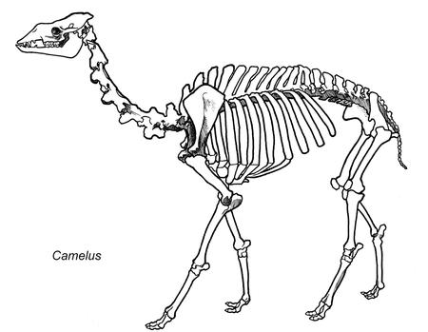

All camels, even *Poebrotherium* and the vicuna, have only two toes on each foot.  This hasn’t changed over time as has the foot structure of the horses.  The two metapodials, the foot bones with which the toes articulate, while generally separate in *Poebrotherium*, but are solidly fused together in later genera.  The overall size of the animal, neck length, and skull vary considerably among the listed camel genera as the illustrations will show.  Despite the similarities that clearly bind them together as camels, the different genera exhibit some rather dramatic differences in size and appearance throughout geologic time.  These comparisons will be made in the later graphics.

**Figure 3.17**  The palates of a fossil *Poebrotherium* (Bottom) and modern *Lama* (Top) are compared to show the lack of major difference in tooth structure over approximately 30 million of years in the camels..

**Figure 3.16**  This chart represents where some of the more important genera of fossil camels are found within the geologic record.  While it is a true picture it is by no means comprehensive or complete.  The purpose here is to paint a general history of the camels to give the understanding that a wide variety of camels have lived throughout the geologic past.  Only two genera are alive today.

**Figure 3.15**The actual three-toed foot bones of *Parahippus* (Top) compared to those of a small fossil *Equus*​ (Bottom).

**Changes in Horse Foot Structure**  
  
The feet in the horse line likewise change dramatically.  *Hyracotherium* has four toes on the front feet and three on the rear.  *Mesohippus* has three toes on both front and rear feet, as do most of the other genera listed on the accompanying chart except *Equus*, *Dinohippus*, and *Pliohippus*.  The drawings of **Figure 3.14**illustrate these changes in the front feet of the horses.

**The Only Living Elephants**.









***Homo erectus***  
  
Estimated age: 1.8 mya to 500,000 (?) ya  
Estimated average brain size: 1,000 cc  
Brow ridges:  Very prominent  
Prognathism: Prominent  
Comments: There is considerable variation in fossil material attributed to *Homo erectus*.

**Figure 3.54***Homo ergaster*.  (KNM-ER 3733) (BONE CLONES® BH- 011.)



**Figure 3.42***Deinotherium*teeth.   Note the considerable difference between these and any other “elephant” teeth.

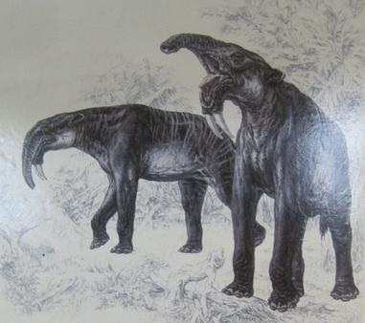

**Figure 3.43**Of all the variety of elephant types that have lived in the last 35 million years or so, only two genera survive.  On the left is the Asian elephant *Elephas*, and on the right the African elephant *Loxodonta*.  The occlusal surface of the teeth of each are  shown in the center.  All pictures are from the Univ. of Nebraska State Museum.

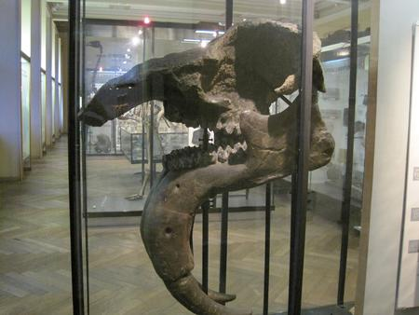

**The Mammoths**

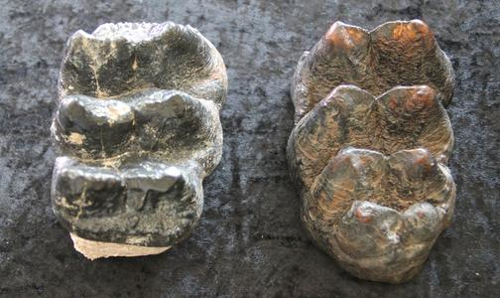

**Figure 3.35**Two typical Mastodon teeth.

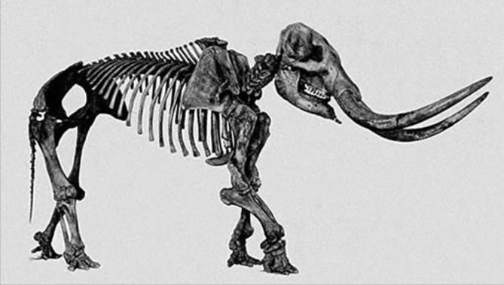

**Figure 3.30***Megabelodon*  Another  Gomphothere from the U.S.  Note the long jaw.  (Univ. of Nebraska State Museum).

**Figure 3.29**  *Gomphotherium* (A defining member of the Gomphothere Group)  Note the long tusks and very elongated lower jaw.  Many had two tusks on the lower jaw as well.  This one lived about 10 million years ago in the Western U.S.  (South Dakota School of Mines and Technology Museum).

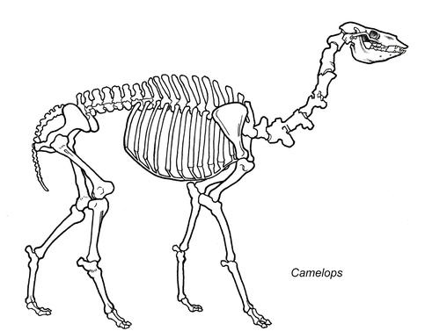

**Figure 3.26**The genus *Camelops* was a common camel in the western United States in late geologic time.  Its fossils are often found along with horses and mammoths in very late deposits.  It is estimated to have died out about 10,000 years ago (Anderson 1984, p.71).  It is quite similar to the living camels (*Camelus*) but 20% or so larger.

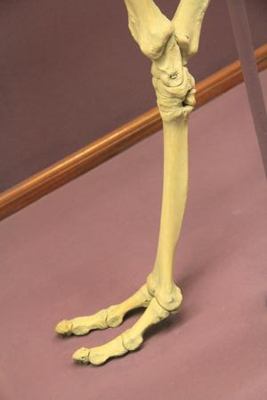

**Figure 3.18**  The fused metapodial of a Late Cenozoic fossil camel.  In*Poebrotherium* this bone was two separate bones.  In all later fossil and living camels it is fused into a single bone.  The metapodial is the foot bone that articulates with the two toes of the camels.

Unlike the horses the cheek tooth form remains remarkably similar over a vast time period.  The tooth crowns may get a little higher in some forms than others but the basic tooth form is quite consistent.  This is illustrated in **Figure 3:17**where the cheek teeth of *Poebrotherium* are compared with a modern Lama.  This is stability of tooth form is certainly different from the substantial tooth change of the horses and elephants through time.

The horse line went through many changes over a period of about 50 million years.  This brief explanation should be adequate to give a reasonable understanding of the major changes involved.  The actual fossil material illustrated should help verify that such changes really did occur in the history of the horse.  A biblically oriented faith must incorporate such knowledge into its understanding of the past history of the earth and life upon it.  
  
How many or which of these changes were brought about by natural selection and which were brought about by intelligent manipulation of some kind is probably impossible to determine with confidence.  This author finds it very difficult to believe that all these changes were purely the result of random natural processes at work.

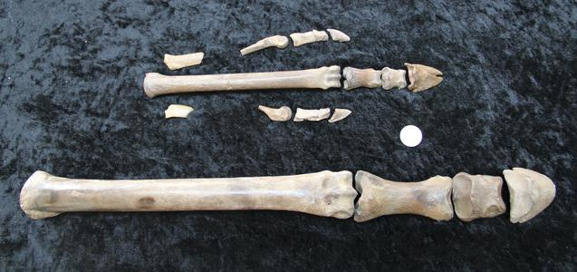

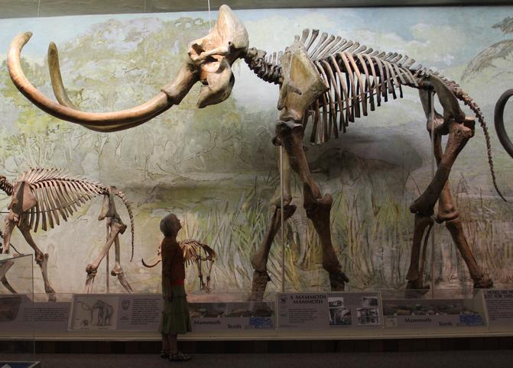

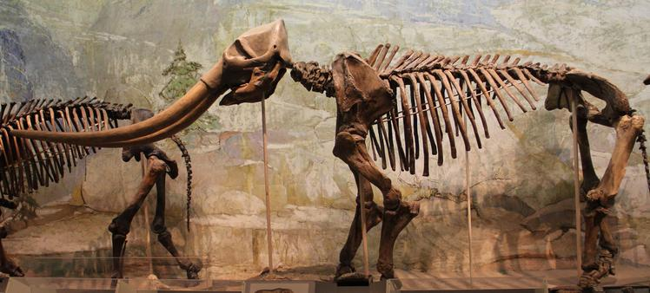

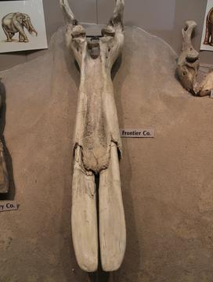



***Paranthropus boisei***  
  
Estimated age: 1.5 to 2.5 mya  
Estimated brain size: 520 cc  
Estimated height: 4 ft 11 in to 5 ft 4 in  
Brow ridges: Very pronounced  
Prognathism: Very pronounced  
Comments: Most have a sagittal crest because of attached heavy chewing muscles.  Some consider it a member of the genus *Australopithecus*.

**Figure 3.51***Australopithecus africanus*. (“Mrs. Ples”)  (Source of cast is unknown.)



***Australopithecus africanus***  
  
Estimated age: 2 to 3 mya  
Estimated brain size: 440 cc  
Estimated height: 4 ft 9 in  
Brow ridges: Very prominent  
Prognathism: Very prominent

**Figure 3:39**Stegodon.  A prominent fossil elephant of SE Asia featured here on an Indian postage stamp.  Its large upper tusks are impressive.  Its teeth are different from all other elephants.  At one time it was thought to be the progenitor of the later elephants because of its tooth structure but it was found that it lived too late to be so.



***Figure 3.38****Mammuthus*teeth.  A wooly mammoth tooth is on the left and a partial Columbian mammoth tooth on the right.  The size difference is quite significant.  A careful look at the Columbian tooth will show that it even has a number of plates missing from the left front.  Note that both are of the same basic design even though very different in size.



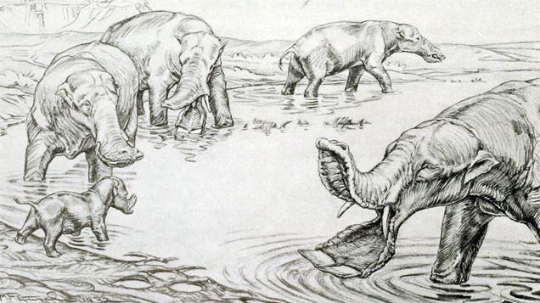

**Figure 3.31 Some uniquely different members of the Gomphothere Group**Left, *Platybelodon* (“The shovel tusked mastodon”) and, right, a lower jaw of *Amebelodon*   (“The spoon billed mastodon”)

("Platybelodon" by Margret Flinsch) (*Amebelodon*​jaw, Univ. of Nebraska State Museum).

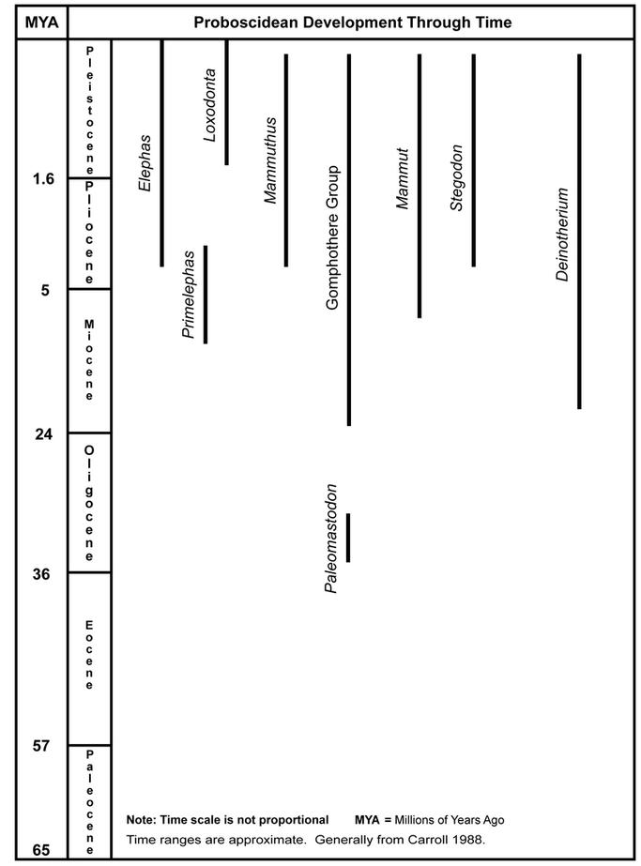

**Figure 3:27**  This chart represents where some of the more important genera of fossil elephants are found within the geologic record.  While it presents a true picture it is by no means comprehensive or complete.

**Figure 3.21**  Above are illustrations to scale of *Poebrotherium* lived in the Oligocene, some 30 million years ago.  Skeletons of this little camel are found in many museums across the United States.  It stood about three feet high.

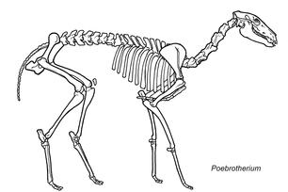

**Figure 3.19**  The two toed foot of the modern camel.  These are the foot bones of the Bactrian camel.  The Field Museum, Chicago.

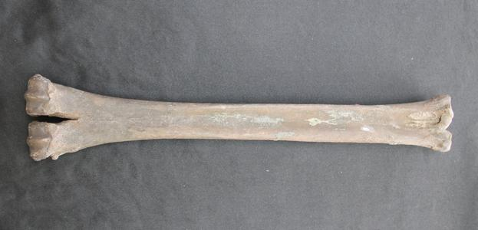



***Homo sapiens***  
  
Estimated age: 150,000 yrs. (?) to present  
Estimated average brain size: 1325 cc  
Brow ridges: nil  
Prognathism: vertical face

**Figure 3.57***Homo neanderthalensis*.  (Source of cast unknown.) 



***Homo neanderthalensis***  
  
Estimated age: 200,000(?) to 35,000 ya  
Estimated average brain size: 1520 cc  
Brow ridges: Very Prominent  
Prognathism: Prominent  
Comments: A larger average brain size than modern *Homo sapiens*..

***Homo ergaster***  
  
Estimated age: 1.75 mya  
Estimated brain size: averages around 1,000 cc  
Brow ridges: Prominent  
Prognathism: Prominent  
Comments: Some consider it a type of *Homo erectus* and not a separate species.

**Figure 3.53***Homo habilis*.  (Source of cast is unknown.)

**The Deinotheres**

​ These are unknown in the New World but were wide spread in the Old World, especially Europe and Africa.

**Figure 3.41***Deinotherium*skull and an Artist's reconstruction, both from the Prague Natural History Museum.

**Figure 3.37***Mammuthus primigenius* (The wooly mammoth)  Fossils of thousands of these are found in Siberia and Alaska.  A model in the Prague Natural History Museum**.**

**Figure 3.36***Mammuthus columbi imperator* (The Imperial mammoth).  This was one huge elephant that walked the Western U.S. plains in very recent times.  (Univ. of Nebraska State Museum).

**The Mastodons**

**The Gomphothere Group**

**Figure 3.27**The genus *Camelus*, one of the two (or three by some authors) living genera of camels.

**A Summary View**  
  
 In looking at the prehistory of Israel and the “biblical” area, we find there was very little human cultural development during the early glacial periods.  The most significant developments, if we consider the nature and quality of the artifacts left, have taken place in the last 40,000 years or so.  Prior to that similar tool cultures lasted for long time periods with little change.  A similar history of change is witnessed in Europe.  It is only within the last 40,000 years or so that an explosion of cultural creativity has taken place.  This includes not only creative tools in wood, stone, bone, and ivory but also art works.  There is tool art, portable art, and the magnificent cave art of southern France and Spain.  
  
Human beings have been around for a long time but their mental skills seemed to have really advanced within the last 40,000 years or so. This escalation of the ability for more highly developed culture continues through the Neolithic of the Middle East and beyond.  By the time we get to 3-4,000 BCE, five or six thousand years ago, we have the full human cultural compliment of written language, law, accounting, developed religion, etc.  This is indeed a remarkable uptick in human culture and the beginning of our Western Culture.  What does it mean?  
  
These are true realities that need to be incorporated into the believer’s faith just like the true nature of the solar system and universe!

**Chapter 5**

**Evolution Is the Product of Intelligence:  
                        The Missing Scientific Proof for Natural Selection**  
  
Materialists often chide believers for “God of the Gaps Thinking.”  However, currently many materialists and popularizers of evolution are guilty of an equivalently non-scientific way of attributing change in the fossil realm.  It could be briefly summarized as: “Natural Selection of the Gaps Thinking.”  It is based more on belief than on science.  True scientific proof of how the changes were actually made in fossil animals is almost, if not totally, impossible to obtain.   Because of this, explaining the changes in the fossil record has moved from “God of the Gaps” thinking” to “Natural Selection of the Gaps” thinking without demanding actual scientific proof for how it was done.  
  
Evaluating the supernatural by scientific methodology is clearly a misapplication of science.  But constructing hypotheses that are impossible test is also a non-scientific endeavor.  When examining the changes in fossil lineages in geologic strata the changes may be confidently attributed to changes in the genetic material of the organism.  However, proving scientifically how or by what means changes in the genetic material were made is, for all practical purposes, impossible for fossil organisms.  Can the results be reproduced?  Yet, almost without fail, the materialist trots out the “Natural Selection of the Gaps Thinking” to explain the change.  
  
The fact that the cause of the change is not scientifically provable is often over looked, or glossed over, by most scientists dealing with the question.  A few have openly acknowledged that fact.  Two prominent paleontologists clearly state this in the introduction to some of their writings.  (Bold emphasis is mine.)  
  
*Philosophers and other non-scientists have often suggested that evolution may have been due to some Supernatural agency or some mysterious “drive” within the animal itself.****No one can prove, of course, that this is not the case****.  But as scientists we attempt to explain the phenomena of nature in terms of natural laws before resorting to supernatural interpretations.  (Alfred S. Romer, The Vertebrate Story*, p. 5, Univ. of Chicago Press, 1959).  
  
*Nevertheless, much of what appears to be a basic human need, that of understanding the place of man in the universe, lies outside the area of descriptive and interpretive science.  These other parts have traditionally been dealt with by theologians and philosophers.  Consequently, this book will deal with what happened in the history of the close relatives of man and of man himself.****Why this happened remains a matter of individual belief.***  (Elwyn L. Simons, Primate Evolution: An Introduction to Man’s Place in Nature, p. v, The Macmillan Co., 1972).  
  
Both of these men had excellent knowledge of what was in the paleontological record.  They acknowledged that why it is there is still an open question.  This is not to imply that they believed that their conclusions on mutation and natural selection were wrong.  They believed they were right.  The importance of the quotes is that they are acknowledging that their conclusions are based on philosophy and belief, not science.  What is in the fossil record is the realm of science.  How it got there is another matter.  
  
Charles Darwin and Alfred Wallace are celebrated because they discovered a natural method that changed animals over time.  This has been given the name natural selection.  The religious dogma of the day was that animals were fixed in their makeup and did not change.  The observations of Darwin and Wallace that animals do change immediately set them at odds with the religious community.   Neither Darwin nor Wallace was aware of the complex genetic system that was responsible for the changes that they discovered.  But they did observe that a natural system was changing animals.  
  
But should we conclude that natural selection was the only, or even the major, mechanism that has made the changes found in animals in the fossil record?  This is a major extrapolation.  
  
Could such changes have been made by supernatural forces if such forces really exist?  Yes, but we can’t evaluate supernatural forces with scientific methodology.  Does this then give anyone license to automatically conclude that natural selection did it? …Without scientific evidence?  What kind of logic is this?  It is logical to posit supernatural forces?  Yes, it is just not scientific, because the supernatural is not subject to evaluation by physical means.  Science is a study of the physical and thus is limited what is physical.  But does that mean that the supernatural must be excluded as a possibility?  Leaving the possibility of a supernatural presence out of the picture may be “scientific,” but it is not logical.  Logic and scientific methodology are two different things.  
  
It would seem that we should only attribute natural selection to situations where natural selection can be scientifically proven to be the mechanism that produced the change in the genetic material of the fossil organisms.  Otherwise we should be honest and say, “We don’t know what caused the change.”  
  
Natural selection, since it is a physical process, should be capable of scientific proof.  If truly scientific it should be subject to reproduction.  Intelligent control by a supernatural force is not subject to scientific proof and is not subject to reproduction.  
  
Genetic material can be changed by internal and/or external forces.  Changes in the genetic material are clearly the mechanism by which evolution proceeds.  The real questions are about what or who made the changes in the genetic material.  The cause of the change may be natural selection, artificial selection by intelligence, or direct, intelligent chemical change of the genetic material by human or supernatural intelligence.  
  
In the evolution of modern dogs the original genetic material, with little doubt, came from the wolf.  However, the changes that made 400 varieties of dogs were produced by the manipulation of that genetic material by the artificial selection of humans.  The major changes made in dogs were not a product of natural selection.  The changes were artificially controlled by human intelligence.  Thus, in the case of dogs, their evolution was driven by human manipulation of their genetic material.  How much more change could have been produced in dogs if the humans at the time had the capability of chemically altering the genetic material rather than just artificially selecting it?  
  
How was the evolution of fossil animal lines driven?  The real question is not whether or not they evolved, but rather what caused that evolution and change? Evolution has occurred in the biological world.  The fossil record clearly proves that.  What the fossil record doesn’t prove is that natural selection was the sole, or even the major, mechanism for that evolution.   
  
Consider an analogy; while not scientific proof it is a logical and meaningful analogy.  
  
Evolution is a major aspect of our lives.  Cultures and cultural features evolve.  Languages evolve.  Technologies are in continual evolution and change.  The reason for these changes is human intelligence.  It proceeds as a creative development process.  We build something; use it for a time, then come up with creative ideas on how to modify it.  So the next time we build it we improve it so it works even better.  This creative development process is a major aspect of the human experience.  
  
Automobiles evolve.  Computers evolve.  Airplanes evolve.  Radio and TV evolve.  It seems nearly impossible to think of any human technology that doesn’t evolve.  Why does human technology evolve?  …Because of the creative power of human intelligence working with that technology.  Technology does not evolve apart from human intelligence.  Intelligence is the driving force for this evolution and change.  
  
Such change is usually not in a direct, upward movement toward a previously visualized “perfect” product.  It is a creatively developing process that unfolds with time and experience.  It is a creative, wondering path, often with many branches, many of which become dead ends.  The end is not seen from the beginning.   I believe this is also the nature of many of the biological progressions and animal lines observed in the fossil record.  
  
The paleontological record shows a similar evolution of design through time for plants, animals and even human beings.  Why should one be so reluctant to conclude that these changes are also the product of the creative development process of an even higher intelligence?   
  
Or why would one unreasonably discount any belief in the existence of such intelligence as a mechanism for change?  Why choose to believe in a weaker force, natural selection, as the major mechanism of evolutionary change?  Especially when there is really so little verifiable and repeatable scientific proof that natural selection produces little more than variation within animal groups?  Natural selection seems to be a mechanism for creating variability within a group of organisms, rather than a mechanism for creating new organisms.  
  
The fact remains that in the paleontological record there is inadequate scientific proof that natural selection has made the major changes found in the lines of fossil organisms.  With scientific methodology we can determine when fossil animals lived and their physical characteristics as far as their preservation will allow.  We can determine what changes occurred in animal lines over time.  We can often date the timing of those changes.  We can test and repeat such observations again and again.  This is science.  What we cannot determine with scientific methodology is what caused the changes in the genetic material to make the animal different.  This is where “Natural Selection of the Gaps Thinking” is employed by the materialist.  
  
Fantastic stories are put together about how complex structures, such as the eye or the amniote egg could have evolved by natural selection. This is not science, it is storytelling and un-testable hypothesis making.  Can they be scientifically tested?  Can the results be reproduced?  The nature of the physical record is such that these hypotheses can never be tested scientifically.  One cannot recreate the animal or its complex environment and have the time to see if the environment can produce the observed structure.  A great extrapolation of the logic and observed facts is necessary to arrive at the conclusion.  
  
What changes, variations and fine tuning, were the result of genetic mixing, drift, and random mutation followed by natural selection and what major changes were the result of intelligent manipulation can probably never be determined scientifically.  This is why the conclusions are most reasonably based on philosophy and belief while taking what can be accurately known for sure from geology and paleontology into proper consideration.  
  
Certainly many observed changes are most logically attributed to natural processes.  This shouldn’t exclude even the origin of some species.  The loss of eyesight or pigment by fish or insects living in lightless caves for long periods of time would seem most logically the result of natural processes; as would be the reduction in size of mammoths that have become isolated on small islands.   Rather dramatic changes also seem to occur regularly in some biological groups.  A common example of such a group is the cichlid fish (Barlow 2000).  The genetic material in some groups would seem to have more variable possibilities than in others.  The wolf line and resulting dogs would seem to indicate a wealth of change possibilities in the genetic material of some groups.  
  
**Misplaced emphasis on transitional forms**  
  
A missing logical link in a sequence of fossils might be the result two different things.  First, poor preservation record may not have preserved the links that actually lived.  On the other hand, if the design process had been an intelligent one, the link may only have existed in the mind of the designer and never have been an actual living entity.  In technology one can find examples of both transitional links and of missing links.  Because either may be true, arguing over missing links and transitional forms in the fossil record can be misleading.  
  
Whether the missing transitional forms ever existed or not remains a factor to consider for both science and belief.   Many major gaps have been filled by transitional fossil forms.  Other thousands more will probably never be filled.  A perfectly seamless transition is almost never found.  We must not eliminate the thousands of legitimate gaps from the evaluation process.  Why do they exist?  Is it really just poor preservation?  That seems unlikely.  There are just too many.  They are an important part of what is in the physical record that must be considered.  However, in specific cases their presence or absence is not definitive.  
  
In human technologies transitional forms may or may not be present.  Consider sequences of automobiles or computers.  Usually transition models exist but many times a substantial leap is made without transitions.  It’s an intelligence thing.  The same variation seems to be true in the sequences of fossil organisms.  
  
**Summary**  
  
To conclude let’s consider a summary of three main ways the changes in an organism’s genetic material may be made:  
  
1. Natural selection based on natural processes selecting beneficial changes brought about by gene mutation,  unique combination of genetic material, genetic drift, recombination, isolation, etc., etc.  
  
2. Artificial selection by intelligence (human or supernatural).  
  
3. Physical chemical changes of the genetic material directly made by intelligence (human or supernatural).  
  
Physically identifying which is true in any particular fossil line is subjective and probably not scientifically provable.  For changes in the fossil record, materialists consider only the first possibility a viable consideration.  While this is definitely scientific, it is not necessarily logical.  A believer has all three possibilities to consider.  It is reasonable to believe we are looking at a creation designed to run without need of constant intervention to fix and patch things.  
  
While I don’t consider myself a part of the Intelligent Design community, I do think there is good reason to consider overall design by intelligence in the biological realm.  There is a need to look outside the science box to find what is indeed true.  
  
Human beings may be animals.  Even Solomon in the Bible considered them such (Ecclesiastes 3:18-21).  But what an amazing animal the human being is!  Who is building the zoo and who is in the zoo?  How many books in the world were written by apes?  What technology was created by apes?   What ape, or group of apes, has the power to destroy the earth?  Would you want your daughter to marry an ape?  Look and think about what a human is and can be!  What a dramatic difference between the two.  This may not be politically correct.  But the author is not a politician.   Let’s open our eyes to balanced and reasoned judgment.  An ape and a man are worlds apart even though they share 98% of their genes!  Apes didn’t go to England to study Jane Goodall and her relatives.

 Wheeled vehicles are clearly a human technology developed by human intelligence.  The pattern of the groups are very similar to the pattern of the development of primates.  This may not represent proof that the primates are the product of intelligent thought processes but it should give reason to seriously consider the possibility.  The creative processes and developmental patterns look very much the same.  
  
The groups could be individually charted as well.  For the automobile group individual lines would clearly become apparent.  Ford, the General Motors group, and Chrysler would be separate lines showing different engineering styles that would separate them as a group, yet their lines would include common advancements like electric starters, automatic transmissions, alternators, etc. through time.  Later would be added Honda, Toyota, and Datsun (Nissan) lines.  There would be many dead end lines like Studebaker, Henry J, etc.  Within the groups would also be many dead end lines like Edsel, Pinto, Corvair, etc.  The analogies keep coming the more one looks into the details.  
  
The main purpose of this chart is to show how mental ideas connect one group to another.  There is no question natural selection here.  Market forces and cultural environment are selection mechanisms that might be equated to natural selection.  However, being driven by intelligence they are artificial, not natural.  This is idea flow, not gene flow.  We would find nearly the same type of pattern in almost all fossil groups if we were to chart them.  
  
A new wheeled vehicle or other technological device is constructed from scratch using a blueprint pattern or ideas in a designer’s head.  While a technological device is changed by building another unit from scratch using a new design, a living organism is self-reproducing under the control of genetic material. A living organism is changed by altering the genetic material by one of the three methods previously mentioned.  
  
Even though improved human technologies are constructed from scratch using basic materials and improved living organisms are built by self-reproduction based on changed genetic material, the patterns of design development show remarkably similar form.  The creative, intelligent, thought processes behind both developmental sequences seem to express themselves in remarkably similar ways.  
  
 Most modern research in paleontology reports research results with a chart called a cladogram.  These are quite different than the chart showing the geologic distribution of primate fossil in Figure 6.1.  Unlike the primate chart a cladogram is not concerned with geologic time and geologic fossil distribution but only with the sequences of change in the genetic material of the fossil groups under study.  The cladogram is a relationship chart of animals based on a computer driven evaluation system.  Changes in genetic material are evaluated by comparing a number of selected characteristic of the fossil organisms.  Since the characteristics are formed by the genetic material this seems a reasonable approach for determining the history of change in the genetic material provided the correct characteristics are chosen to evaluate.  
  
Since changes in an organism are made by altering the genetic material, whether that change is made by natural selection, artificial selection, or intelligent manipulation of the genetic material it would seem that the cladogram would yield the same results.  Thus a history of even intelligent manipulation of the genetic material should be preserved in a cladogram if the evaluation process is accurate.  
  
When considering the history of automobiles a well constructed cladogram should work there as well.  Well selected characteristics of things like carburetors and ignition system components would separate automobiles from companies like Ford, Chrysler, General Motors, Honda, and Toyota from one another.  It should even separate out the older lines of General Motors like Chevrolet, Pontiac, Oldsmobile, and Cadillac. To create such a meaningful cladogram one would have to know many individual automobiles very thoroughly.  The same is true for paleontologists who construct cladograms for fossil animal lines.  
  
The magnitude and complexity of many observed changes in the fossil record seems, to this author, to cry out for more powerful intelligent intervention rather than the rather weak natural selection processes.  Certainly one has to be careful making specific judgments.  It is difficult, and probably impossible, to know the exact limits of the natural processes.  However, simply extrapolating them to cover all change is neither scientific nor rational.  To the author it seems very irrational.  But when that is the only mechanism one has, it’s what has to be used.  
  
Many mistakes have been made by believers in the past by claiming that God specially intervened and did something when natural processes were probably at work.  This is true in the evolution of animals as well as the cause of earthquakes, volcanoes, and other natural phenomena.  The issue here is judging what is most likely true.  It is about judgment and faith. Science helps but doesn’t give a full answer.  One does not honor an intelligent God by stating things that are not true.  Granted, perfect truth is illusive.  But the believer must apply the best, most rational judgment, and thought.  They must be willing to change their view when strong evidence shows that their conclusions were probably wrong.  Faith must always be subject to truth.  Truth is trump!  
  
On the other hand, one cannot wait for absolutely perfect knowledge before making all decisions.  Life would be gone before one decided how to live it.  This is one reason why faith, based on judgment, is such a necessity.  The brevity of life requires each of us to make judgments based upon what we conclude is most likely true.  
  
For the believer, faith is that there was an intelligent creator making changes and overseeing those made by natural selection.  For the materialist, faith is that natural selection is the only creator.  Both are faith, not science.  But scientific facts should be used to evaluate both faiths.  
  
   
  
**Summary**  
  
It is with all this in mind that I present a different way of looking at the changes in the fossil record through time.  It seems the most appropriate name for this process is Creative Development.  
  
It is not based on a materialistic philosophy but rather on the existence of the superhuman intelligence revealed in the Bible as “God.”  This process does not knowingly ignore or exclude any of the physical scientific evidence.  It merely views that scientific evidence from a different perspective.  That perspective is an ongoing, creatively developing process directed by intelligence.  There are dead ends and quick turns to many designs.  The fossil record is replete with these which are difficult understand by mere natural selection processes. For those conversant with the fossil record this would be most exemplified by, but not limited to, “radiation events.”  The radical diversification of mammal lines in the early Cenozoic is one example of such an event.  
  
I am suggesting an intelligent, creative process.  The exact end points are not known from the beginning.  This is not an expression of orthogenesis.  It is a process of ongoing, creative design to make something better.  This is similar to what happens in nearly every human technology, from automobiles and computers to bottle and can closures.  Even paper clip technology has evolved through time.  I think the same process is shown in the fossil record of living organisms.  
  
 .

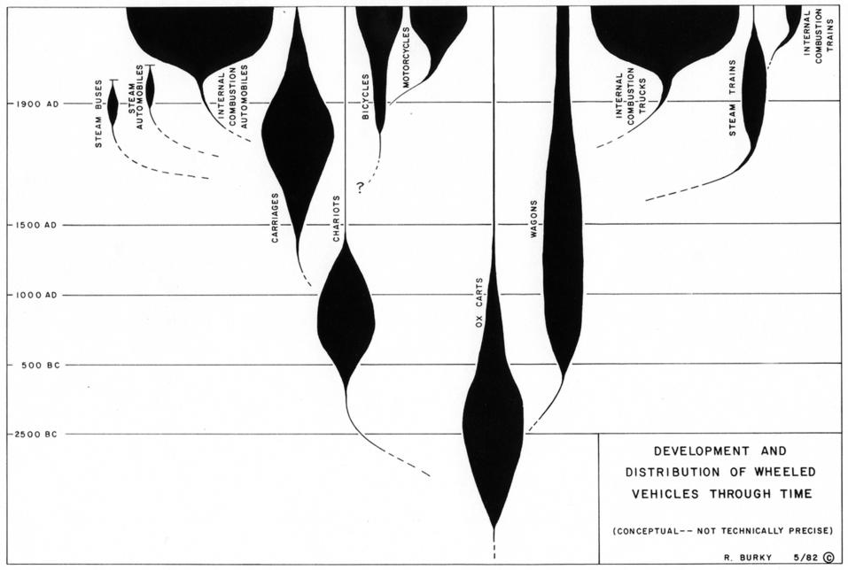

This chart shows the various groups of primates and where they occur in the geologic strata.  The dotted lines indicate an absence of fossils and uncertain linkages between groups.  We would certainly attribute some of those dotted lines to forms that will be found someday.  But on the other hand there are so many missing parts of the picture it is hard not to believe that many of the gaps are real.  If one were to take each unified group and graph the individual genera in it, a similar set of disconnected  groups would be seen.  There are innumerable “missing links” in the fossil record.  Links present or links missing are neither certain proof of intelligence nor proof contrary to it (See Chapter 5).  They should , however, be taken into account when making judgments on the cause of the changes made in organisms in the fossil record.  
  
A better understanding of this chart, for those not familiar with the fossil record of the primates, should come as we consider the next chart, constructed in a similar fashion but covering a human technology with which most are generally familiar.  The comparison is presented as an analogy, not as some sort of scientific proof.  It does however present a way of looking at the fossil record from the perspective of intelligent development rather than mindless meandering.  It provides an example of how human intelligence creates technology over time.  The chart is reasonable, but hypothetical.  Precise historic data were not compiled to construct the graph.  A graph line is wider to show that a greater variety of wheeled vehicles of the labeled type are present at the time.  The same is true for the primate chart.  The wider the lines the more variety of primates of that group were living at the time.  
  
Also true for both charts, an organism or a vehicle included within a group may not be securely attached to the group by genes or design but simply be included because that is the closest fit by definition.  For example, a pickup truck might be included in the truck category by some and in the automobile group by others.  
  
**Figure 6.2  A hypothetical historical analysis of wheeled vehicles.**

​

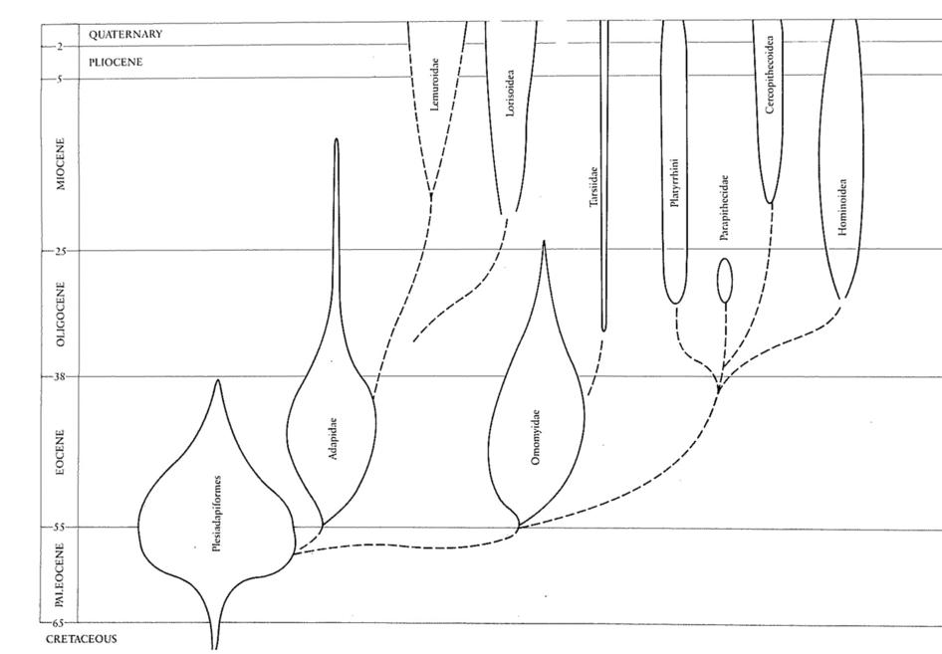

**Chapter 6  Creative Development: A Viable Paradigm**  
  
 Evolution of the biological world is a reality.  The fossil record is a complex record that reveals how this has occurred over vast periods of geologic time.  Scientific methodology proves this to be true.  The chief question that science cannot prove is what really caused these changes?  
  
As we examined in Chapter 5, the answer is generally based more on the philosophy, practice, and belief than on provable science.  The materialist who has discarded any possibility of the existence of supernatural intelligence is necessarily limited to the physical process of natural selection.  Natural selection working on the random changes produced by mutation and other genetic variability does produce changes in living organisms.  However, this is a weak and limited change mechanism.  To project it as the cause of the major changes in fossil lines requires considerable extrapolation from the observed changes made in living organisms.  
  
The extrapolated application of natural selection is not subject to scientific proof or reproduction.  This is a serious obstacle to its being called “scientific.”  It is usually a non-scientific conclusion made because it is the only mechanism considered possible.  Maybe the correct answer is outside the “science box.”  
  
This chapter presents a non-scientific hypothesis or conclusion that is rational and fits the observed scientific facts even better.  I call it Creative Development.  It is not scientific and subject to testing by scientific methodology because it allows for the operation of intelligence.  Results of intelligent manipulation cannot be scientifically proven.  The results can be seen but the cause cannot be proven.  The cause has to be evaluated by reasoned judgment.     
  
Intelligence, human or supernatural, works outside the realm of scientific, mechanistic evaluation.  Events in archaeology often have to be evaluated in this manner because we are dealing with human intelligence, not scientific mechanisms.  A common example of this is trying to prove whether a stone “tool” was formed by natural processes or by the intelligent manipulation of human intelligence.  A sound judgment can often be made rather easily based on context but proving it scientifically is difficult.  In questionable contexts it has often led to endless arguments.  
  
The overall fashioning of the biosphere by supernatural intelligence is a reasonable and rational conclusion for a believer in spite of the vociferous contentions of many materialists.  The materialists are entitled to their opinion.  But their way of thinking is not a gold standard that must be enforced on others.  Believers are also entitled to rational and clearly thought out opinions that are in harmony with the physical evidence.  The believer need not be forced to limit thinking to physical forces alone.  In fact, this is the believer’s strength in evaluating the geologic past.  However, this doesn’t grant the believer license to ignore, twist, misrepresent, or misunderstand the true nature of the geological, paleontological, paleoanthropological,  archaeological, or historical records!   
  
One who allows for the existence of a supernatural intelligence has a greater range of reasonable possibilities for understanding the fossil record than does one whose thinking is limited to materialistic, natural selection processes alone.  Consider the following.  
  
In the development and change of living organisms through time…  
  
Natural selection is a weak force.  
  
Artificial selection by intelligence (human or supernatural) is a stronger force.  
  
Intelligent manipulation and change of the gene chemistry is an even stronger force.  
  
The biosphere has been developed in an evolutionary pattern.  But human technologies develop in the same way.  This is how humans think and create.  Intelligence drives an evolutionary pattern.  Is it unreasonable to consider that supernatural intelligence might also function in this same way?  I believe this is one thing the paleontological record is showing us.  
  
There are patterns in the fossils that show a creative development process has taken place over a very long time period.  It should not be implied that the end was not known from the beginning.  This is an artificial construct often imposed upon the natural world by some believers.  Such a conclusion doesn’t fit the fossil data.  Organisms appear in the fossil record and are then naturally and/or intelligently modified through time.  Some change, even the development of new species, may be due entirely too natural processes.  However, the overall structure and pattern of the fossil development is best defined by intelligent control.  Where natural processes, or intelligently driven ones, start and end is certainly subject to judgment and debate.  That changes have occurred can be scientifically proven.  The cause of those changes most often cannot be scientifically proven and certainly the changes cannot be reproduced.   
  
Reproduction is necessary to prove scientific results.  It is the key scientific proof that is nearly always lacking for changes attributed to natural selection.  
  
The mechanism causing the change is not necessarily an either/or question as supposed by many.  One answer does not fit all the observed changes.  For example, when one looks at similar groups or families of fish and birds it is very hard not to conclude that many have been altered by natural selective forces in variable environments.  Darwin’s finches may be an example.  The more recently studied cichlid fish of Africa and South America seem a much more powerful example. (Barlow, 2000)  Was there intelligent intervention to make every little change in these groups?  That seems very doubtful.  It would seem much more likely that the genetic system was designed to make such changes in conjunction with environmental change to allow the animal groups to continue to live and thrive.  Gene flow and natural selection do introduce a lot of change in animals.  However, when considering the fossil record, or modern animal breeding, there seems to be a limit to the magnitude of such natural change.   
  
Presented in this chapter is a way of looking at the fossil record from the prospective of an intelligently driven evolutionary process that has been labeled, Creative Development.  
  
The intelligence behind this development process is considered that “God” revealed in the Bible.  (“God” was the term that made sense to those who wrote the Bible, while Supreme Intelligence might be more meaningful in a modern context.)  In the Bible that intelligence is described as moral, eternal, and with unlimited power from a human perspective.  This was a God totally unlike any of the gods of the surrounding nations.  Neither male nor female, and without a form that could be molded into a physical image.  That God is still a viable concept while all the other gods of the surrounding nations have long since disappeared.  Nearly half of the world’s population holds some type of belief in the biblical God.  Are these issues not significant to consider?  
  
When considering the Bible as a source of understanding, don’t stop at Genesis.  The Bible is an expanding  (evolving, if you will!) explanation of that God which was over 2,000 years in the making.  The final picture is much more complete than the starting picture.  See Chapter 10 for a more complete picture.  
  
The believer has a legitimate and rational basis to believe in the existence of an eternal, supreme intelligence as a creator rather than accepting the creation as a mere purposeless operation of natural forces. The Bible gives a “face” to this otherwise shadowy figure of mere rational conclusion.  It also reveals that this supreme intelligence has many intelligent “assistants” available to do the work as well.  It gives a unique purpose for modern human kind and outlines an unparalleled moral way of life.  
  
This intelligent, ever-living being was revealed to a people who had no idea of the size and extent of the solar system and universe.  Not any real concept of geologic time and the vast array and pattern of organisms that had lived in ages past.  As they recorded this material they did so with their understanding of reality.  Later editors and translators also had an effect on the writings.  Many believers, especially fundamentalist oriented ones, lock in on this lack of knowledge and understanding as a part of their belief system, rather than letting the physical record reveal its own truth.  One must take into account these realities and modify this aspect of biblical understanding without discarding the rest of its important knowledge and revelation.  
  
Creative Development is presented as a way to bring the physical record into harmony with key principles revealed in the Bible, especially, God as Creator.  It in no way rejects any of the natural processes that can be scientifically proven to have occurred.  Its primary purpose is to add an over arching perspective that reveals intelligence at work, not mere physical forces blindly forming a creation.  
  
The data from the fossil record is so complex that it unfortunately has to be presented in a simplified form.  Simplifying it means that certain glosses have been made.  This modifies our perception of the true reality but that seems unavoidable.  What is being presented is an overview.  The chart below on fossil primates is taken from a leading paleontology textbook (Carroll1988:466).  
  
**Figure 6.1  Fossil Primate GroupsType your paragraph here.**

**Chapter 7  A Rationale for Faith Based on the Bible**  
  
The Importance of Faith  
  
Humans will always need faith and philosophy to deal effectively with the meaningful big questions of life that are not subject to scientific evaluation.  Faith is, or should be, a decision based on the best possible information subjected to effective, rational thought.  It should not be blind faith based on poor information, emotional whim, or irrational conclusions.  It should not be passively adopted from tradition and culture.  It should be in harmony with known scientific fact.  The bottom line, however, is that it is faith.  It is not science nor can it be proven by scientific methodology.   
  
Faith has to be a complete and unified whole to be an effective guide in life.  It can’t be exclusive of scientific or other truthful information.  It should not, however, be so rigidly crystallized that it cannot change when new information is obtained.  Faith needs to be a trusted conclusion that allows life to move forward with confidence, meaning, and effectiveness.  One cannot wait 50 years to get all the data needed to figure out how to live one’s life.  Decisions need to be made in a timely manner.    Faith allows immediate decisions to be made and future plans to be structured.  Faith is extremely necessary and practical for human beings.  Religion and/or philosophy generally provide the foundation for faith.  In this chapter we consider using the Bible as a reasonable foundation for a viable faith.  
  
It has often been said that man makes god in his image.  This is certainly true in many cases.  But a god thus created is indeed a worthless god.  If such a god forms the basis of a religion that becomes entrenched in a human culture, belief in that god may be an emotional crutch and support to those of that culture, but it is worthless in terms of intrinsic value and truth.  Indeed, religions like these have been created by the hundreds.  Some individuals even consider the most basic, primitive, animistic religion as meaningful and important as any modern religion.  But all religions were not created equally or of equal validity.  Biblical religion and faith are totally different.  This fact must be adequately emphasized and considered.  
  
 The Bible is not a record of man creating God in his image.  It is an image imposed upon the readers and hearers.  If we take the Bible at face value it is the story of how a God was revealing Himself, His nature, and His character to human beings over a period of approximately 2,000 years.  He, or ones sent by Him, did not appear just once, but innumerable times to many different people over a long time span.  He was not fashioned by man.  Rather He imposed Himself upon them.  He is an invisible God for whom no image was to be made or worshipped.  This God is one who claims to have controlled the creation of everything that exists, including human beings themselves.  The Bible is no quickly fabricated story.  It unfolded over a 2,000 year time span.  It was recorded, edited, and translated by hundreds of people.  Yet, its story is amazingly simple and unified throughout when adequately understood.  With so many authors contributing over such a long time spread, it is indeed remarkable that the Bible’s message is so uniform and clear. (Consider chapter 10).  
  
The continuous cultural history of the biblical story starts in chapter 12 of the Book of Genesis with the story of Abraham.  (The evaluation of the material contained in Genesis chapters 1-11 is discussed in chapter 9 of this book.)  The man, originally named Abram, was the offspring of an idol worshipping family (Joshua 24:2).  He is commanded to leave his native environment and family and to establish a new culture based on God’s laws and ways.  This is the real starting place of the continuing culture that follows throughout the rest of the Bible.  This Abram, whose name was changed to Abraham, is today seen as the “spiritual” progenitor of half of the religions of the modern world’s population.  This includes two billion Christians, 1.3 billion Muslims, and a multitude of Jews that trace their religion back to Abraham.  The very magnitude of this cultural phenomena should cause one to pause and consider what this individual and his story might mean.  This is not an obscure and meaningless event in the origin of modern culture even if one discounts faith based on the Bible.  
  
As a result of Abraham’s faithfulness God promised to work through his family.  This family continued for 2,000 years of biblical history up through the Jew, Jesus.  Of course the legacy of Jesus continues to the present time.  
  
The culture of this religion continued to be developed through the human family of Abraham.  First through his son Isaac, then through his grandson, Jacob, whose name was changed to Israel.  (The Muslims trace their religious history through the Arab line from Abraham’s older son who was half Egyptian, Ishmael.)  As Jacob’s family grew large it ultimately became a nation that took on the name Israel.  With this nation and culture we have the biblical stories of Moses and a whole series of leaders, kings, and prophets.  
  
By the biblical record, a small group of Abraham’s descendents were taken into Egypt, the greatest nation of the world in that day.  After many years, when they had multiplied considerably, a later Pharaoh made them into slaves.  We have the story of their deliverance from that slavery and their establishment as an independent nation in the general area of modern Israel through a series of miraculous events.  
  
From the evidence of archaeology the truth of most of these stories can neither be totally verified, nor denied.  The stories are logical and reasonable in the known historic setting.  Connecting actual evidence on the ground is much more difficult.  This is, of course, true of most of written history.  We tend to demand more evidence from the Bible because of its importance.  Biblical scholars and archaeologists come down on both sides of the issue.  Bias and prejudice abound in the argument.  Patience is needed with the archaeological record, and the archaeologists, to get enough solid data to be on firm ground scientifically with conclusions.  As far as faith is concerned, we have to make a judgment on the matter and move on.  Making the exact details of archaeology the major proof for our faith is unwise.  There is better, sounder evidence upon which to base faith.  
  
As we get into later times the historical and archaeological evidence become clearer.  The archaeological evidence of New Testament times and locations is abundant.  Don’t expect to find archaeological evidence for Jesus himself.  How much of an archaeological record would we expect to find of an early first century thirty three year old wandering teacher who himself left no written record?  Who built no fantastic buildings or monuments?  One must understand the nature of the archaeological record.  There is, however, an abundant record of his environment, the Jerusalem temple, the Roman buildings and towns, etc.  
  
His real history though, is in the legacy He left.  His disciples and other followers established multitudes of institutions that spread out from the area into the entire world.  Many of these continue to this day.  Were these built on just an empty story in a book?  
  
How are we to evaluate the Bible?  Are the biblical stories mere fabrications and fictional?  Are all the details exactly precise?  What would we expect from a humanly written book?  
  
The Bible has probably prompted more arguments than any other book in history.  Who wrote it?  When?  What does it mean?  Books and even libraries of books have been written on these subjects.  Many fundamentalists conclude that God has directly inspired its every word of the Bible.  At the other extreme, many modern scholars, even some theologians, consider some of it to be an outright fraud, made up and written much later than the scriptures themselves would indicate, and for somewhat dubious, or even devious, purposes.  
  
One has to realize many discredit the authority of the Bible because they want to, not because the facts force them to.  Others are responding to disprove an erroneous fundamentalist interpretation of the Bible.  There are all sorts of contrary voices out there.  If we give credence to the Bible as a history of past events without demanding unreasonable perfection from the human writers it would seem we have the most reasonable chance of being correct.  It is clear from merely reading the Bible that it was written by many people over a long period of time.  Also, that editors later added things to stories already written.  Certainly Moses did not call himself the meekest man alive (Num. 12:3).  Neither did he record his own death (Deut. 34).  Solomon apparently wrote many of the Proverbs, but men of king Hezekiah who lived 250 years after Solomon added to the book of proverbs (Prov. 25:1).   
  
The Bible did not fall down from heaven intact, translated into King James English.  It had a human origin but that doesn’t negate inspiration from God.  The Bible purports to be a record of man’s interaction with his Creator.  Some of its words are God’s words others are not.  From the interaction of God with men His mind, character, and nature are understood and thus revealed.  To make it more than this may put one on a questionable course.  To ignore or trash such a record would be foolish.  
  
Consider Jesus.  Here is the cornerstone or capstone of the Bible.  For some reason He wrote no books even though He was literate.  Because of His teaching and the works He performed he was considered a “super” human being, literally the Son of God.  One who came from God to become human for a short period of time.  This would seem to be the ultimate anti-materialistic claim.  Why should we believe it?  
  
His teachings show a genius in spiritual understanding.  His grasp on spiritual matters was far above that of the religious leaders and scholars of his day.  Where did this uncanny comprehension come from?  He was the son of a builder who worked with his hands.  He was not a professionally trained scholar.  He could read, and obviously had read, the scriptures a lot.  This spiritual genius that is reflected in the Gospel writings is one of the factors that should cause us to consider why Jesus is special.  
  
One of the unique things about his ministry is the miracles that are reported by the Gospel writers.  Blind people were made to see.  Three times dead were raised to life (Son of the widow at Nain Luke 7:14; daughter of Jairus Luke 8:54; Lazarus John 11:43).  Many sick people were healed.  Many gallons of water turned into wine.  These are based on eyewitness accounts.  Are these all fabrications and lies?  
  
Can these miracles be proven scientifically? No.  By archaeology? No.  What evidence are we left with?  The witnesses reporting these incidents who went on to give their lives because they believed in the veracity of what they saw, experienced, and were taught.  Though not repeatable and thus not “scientific,” the fact is that these miracles launched such a major movement as Christianity is evidence worth considering.   
  
We should also consider the experience of the Apostle Paul.  He hated and persecuted the early Christians.  On his way to Damascus to take Christians prisoners and drag them back to Jerusalem for persecution, he had a dramatic, life changing, miraculous experience that made his life take a 180º reverse direction.  He ultimately became a leading apostle to the non-Jews.  What he previously hated he then taught as the absolute truth of life.  And he did this at constant threat of loss of life and limb.  Was he a fraud or liar?  Did he do it for money?  Was this some type of mental aberration?  Or was it a true, life changing miracle?  Is there any question that we have many of his writings explaining his faith, teaching, and experience?  
  
Such non-understandable events or “miracles” are automatically screened out when evaluated through a materialistic philosophy.  This is one reason why so many modern academic people reject them.  I believe they are a reasonable basis for faith because of their context and the teaching with which they are associated.  
  
Miracles do not necessarily contradict science.  They are events that are outside the usual experience.  Even 300 years ago airplanes, automobiles, radio, TV, sound and video reproduction, computers, etc. would have been “miracles” if they were shown at that time.  Yet they all function within scientific law.  In fact, they can only function because of scientific laws.  Interestingly, they too have all also “evolved.”  They have done so because of human intelligence.  
  
Often miracles are misread.  Consider the “miracle” of the virgin birth of Jesus.  Mary was pregnant before she had sexual intercourse with Joseph.  This is something we have to take on face value.  We certainly cannot go back and prove whether or not she had sex with Joseph before they were married.  What is the “miracle?”  It may only mean a sperm was introduced into her womb by some other means than physical intercourse.  Could a competent gynecologist do that today?  How much of a “miracle” would it have taken to do that?   Of course it is equally difficult to understand how the combining of a simple egg and sperm can create a functioning and thinking adult human being that can live for 70 or 80 years.  
  
Raising the dead is an entirely different issue.  That would require use of some force, energy, or method totally unknown to us today.  Is there a way to reassemble all the quanta that make up the person back into their previous location and condition?  If that were possible that would surely restore the original individual.   
  
Another key point to consider is that one of the key ethical points throughout the Bible, New and Old Testament, was against being a liar or a false witness.  The adversary was “a liar from the beginning,” while the true believer was to be faithful witness and only tell the truth.  
  
The Apostle Peter discusses his approach in his New Testament epistle.  
  
2 Peter 1:16-18 (NIV)  
16 We did not follow cleverly invented stories when we told you about the power and coming of our Lord Jesus Christ, but we were eyewitnesses of his majesty. 17 For he received honor and glory from God the Father when the voice came to him from the Majestic Glory, saying, “This is my Son, whom I love; with him I am well pleased.” 18 We ourselves heard this voice that came from heaven when we were with him on the sacred mountain.  
  
Peter said, this is what we heard and saw.  He had no idea what the mechanisms were that made the situations work.  Such eyewitness accounts are reasonable evidence to be considered but they are not scientific proof.  Proving the veracity of such accounts is outside the reach of the scientific method.  As such, they are summarily dismissed by a materialistic philosophy.  
  
One of the most important aspects of the Bible to foster faith is the amazingly simple and yet profound morality it teaches.  From the ten simple commandments of the Old Testament to the character summarizing traits listed by the Apostle Paul… Love, Joy, Peace, Patience, Kindness, Goodness, Faithfulness, Humility, and Self Control (Galatians 5:22-23).  
  
Consider even the neglected 4th commandment.  What would it mean for a society to take one paid day off each week for physical, mental, and spiritual rejuvenation?  What would this do for the society’s health and well being?  
  
A summary of reasons to have confidence in a biblically based faith  
  
1. From the Old Testament commandments to the moral ethics of Jesus, Paul, and the Apostles, the Bible has a simple, practical system of moral ethics that is without equal.  
  
2. The Bible is one of few religious books that points to a logical and reasonable Creator.  It maintains and elucidates that topic from beginning to end.  The story moves from a parabolic vagueness to more realistic considerations as the time of writing progresses. The complex design features of earth and life cry out for such an overseeing designer and creator in the judgment of many of us.  
  
3. The credible eyewitness accounts of faithful individuals of the miraculous and “supernatural” events produced by the biblical God and Jesus.  
  
4. The Bible gives logical and reasonable comprehensive answers to the questions of who we are, why we are here, how we should live, and the possibilities of an everlasting life.  
  
5. The lack of any better alternative, one that makes more sense, in which to believe.  
  
In conclusion:  
  
Here is a mystery to leave with the reader.  The Bible is not meant by its writers to be a book that everyone understands.  Contrary to popular opinion, this seems to be by design.  Take note of quotes by both Isaiah and Jesus.  Isaiah said…  
  
But the word of the Lord was to them, “Precept upon precept, precept upon precept, Line upon line, line upon line, Here a little, there a little,” That they might go and fall backward, and be broken And snared and caught.  (Isaiah 28:13 (NKJV))  
  
 Jesus said…  
  
And the disciples came and said to Him, “Why do You speak to them in parables?” 11 He answered and said to them, “Because it has been given to you to know the mysteries of the kingdom of heaven, but to them it has not been given. 12 For whoever has, to him more will be given, and he will have abundance; but whoever does not have, even what he has will be taken away from him. 13 Therefore I speak to them in parables, because seeing they do not see, and hearing they do not hear, nor do they understand. 14 And in them the prophecy of Isaiah is fulfilled, which says: ‘Hearing you will hear and shall not understand, And seeing you will see and not perceive; 15 For the hearts of this people have grown dull. Their ears are hard of hearing, And their eyes they have closed, Lest they should see with their eyes and hear with their ears, Lest they should understand with their hearts and turn, So that I should heal them. (Matthew 13:10-15 (NKJV))  
  
The modern Bible is the work of probably hundreds of human writers, editors, copyists, and translators over a period of 4,000 years!  The basic story and morality of the Bible hangs together from beginning to end, which is remarkable.   
  
A biblical faith and/or philosophy requires belief in an unseen realm beyond the material world that can be neither proven nor falsified by materialistic science.  However, what can’t be determined by science may be evaluated by other means.  This doesn’t give the believer license to believe things contrary to science.  Truth can only form a whole picture.  Faith and science should provide a complimentary, and truthful, picture of the whole.  Such a faith does not require a fundamentalistic belief in the “perfection” of the Bible, nor does it reject the findings of the sciences of geology, paleontology, or archaeology.  
  
Much of the Bible is recorded from eyewitness accounts.  This is not science but neither does such a source make it bogus.  It must be analyzed and considered on a different basis.  It is not the purpose here to examine all the evidence from a historic perspective or to judge all the eyewitness accounts for their veracity.  One has to judge them in much the same way as one would judge other written history.  
  
If one emasculates the Bible of its supernatural content with a materialistic razor, as is popular with many academics and even modern theologians, one strips it of its unique meaning and strength.  But this is done on the basis of philosophy, not science.   
  
On the other hand, one should not interpret the Bible in such a manner that sets its meaning in contradiction to scientific fact as many modern fundamentalists do.  This is foolishness of the other extreme.  If one follows a fundamentalistic approach and overstates the Bible’s literalness and nature of composition, it is forced into contradiction with the truth.  This makes such a fundamentalist a false witness.   Such an approach undermines the Bible’s veracity and authority.  If we imply a physical perfection of content when that is not its true nature, we become false witnesses to its meaning.  
  
The Bible introduces us to the supernatural realm through eyewitness accounts and also reveals to us a grand reason and purpose for human life.  It gives a clear and authoritative morality to live by.  This is something science does not do.  The Bible provides illumination and vision to the blind spot of science.  This is what true religion and true faith should do.

**Chapter 8  Evaluating Genesis 1 to 11**  
  
To say that the early Genesis scriptures are without meaningful spiritual insight is incorrect.  However, to view them as literal step-by-step descriptions of how the earth and life upon it were formed from nothing in a very short time period is contrary to the solid physical evidence from the geology, paleontology, and archaeology.  To evaluate these early scriptures in such a manner forces them to be in error.  Why should one force such an interpretation when it contradicts reality?  
  
How then can we evaluate these scriptures?  
  
The early chapters of the Book of Genesis have played an important role in introducing the Bible as a collection of writings that introduce the existence of a Creator God.  It makes several clear, simple points.  Here are a few obvious ones, but not a complete list.  
  
1. There is an intelligent Creator who made everything that exists.  He should be worshipped, not the things He created.  The sun, moon, stars, and animals are created things, not gods.  
  
2. There also exists a powerful contrary spirit being who works at counter purposes to the right understanding and ways of the Creator.  Humans are given the choice of following the Creator’s way that leads to life, or of following the way of this adversary that leads to ultimate death.  
  
 3. The Creator established the human family relationship.  He established that a man should leave his parents and be joined to one wife in a permanent bond.  This forms a balanced, supportive environment for any children that might come along.   
  
 4. A seven day week was established. The seventh day was to be set aside for physical, mental, and spiritual rest and rejuvenation.  
  
These basic principles continue without change throughout the rest of the entire Bible.  How literal or parabolic these statements should be taken is open to judgment.  
  
Most of the controversy over the early chapters of Genesis is introduced when an attempt is made to extract more than the basic lessons from them.  If one demands a fundamental literalness and precise definition of all words and stories, rather than letting some of them be poetic, parabolic, figurative, or culturally defined, the material becomes more difficult to understand.     
  
In the New Testament Jesus extensively taught using many “non-literal” forms of teaching.  His parables are well known.  In John 16:25 He told his disciples plainly that He had taught them things in figurative language.  Why should one reject a similar approach to the stories in the early chapters of Genesis?  Why demand that the examples in Genesis be absolutely literal?  The basic spiritual lessons remain valid whether the teaching method is literal or figurative.  (The reader is directed to the Introduction for an outline of how the author would deal with the general question of Biblical interpretation.)  
  
The way Genesis was written has served its purpose for hundreds of generations.  It is not until modern times with the explosion of knowledge that we are required to evaluate more precisely how we understand the book.  Having the content written in a non-literal way allows for simplification.  How could a literal explanation covering all of prehistory have even been written and preserved at the time?  How could it have been understood by all the intervening generations?  Simple, non-literal stories served the purpose much more effectively.  This only becomes a problem when we expect and interpret them to have been written in a modern, literal style, rather than in the style of the day.  
  
Modern authors write novels to put ideas across and to entertain.  Everyone accepts that these are not literally true.  This is part of our culture.  We accept novels for what they are.  If someone in the future were to fail to understand this and interpret them as literal history it could create all sorts of confusion.   The early chapters of Genesis may have a different but similar cultural distortion.  
  
Consider one of Jesus’ parables.  The parable of the Good Samaritan resonates with us because of the lesson in it.  It is of little consequence whether it literally happened or not.   If we question its veracity based on whether or not it really happened, rather than the lesson conveyed, we distort its purpose.  We can do the same with the early chapters of Genesis.  Can we let some of them simply be teaching stories?  Or must we interpret them in a way that contradicts the clear scientific evidence of the prehistoric time periods?  
  
When the prophet Nathan confronted David about his sin with Bathsheba he did so with the help of a fictional story.  That method worked wonderfully, even if David did at first misunderstand it.  
  
Textual evaluation indicates that this part of the Bible was written, edited, and compiled by a number of different individuals.  The author does not have the academic background  to evaluate the veracity of much of this work, but there seems little reason not to accept such conclusions.  Nowhere in the Bible does it indicate when or by whom the early chapters of Genesis were written.  By faith one can give God credit for allowing it to be included in the scriptural cannon.  Its moral teaching is in harmony with the rest of the Bible.  But what is the nature of its inspiration? Should we infuse the words and stories with great hidden scientific meaning?  Or should we not conclude that this was written by non-scientific individuals, to non-scientific people, in a non-scientific age, and evaluate its meaning on this basis?  Should we not evaluate the stories from the cultural context and point of view in which they were written?  I think so.  
  
What is read into, and demanded of, Genesis can destroy its credibility.  Herein lays the key problem.  It would seem to this author to be the height of extrapolation, to an absurd level, to read the “Big Bang” into the creation accounts of Genesis.  Yet, some fundamentalists seriously do that very thing.  Others like to use Genesis as some sort of coded book.  This author would consider both approaches to be in error.  
  
The Bible, when viewed as a unit, is a progressive revelation about who and what God is, as well as, his purpose for human beings.  The history of any science or knowledge follows a similar progression.  The early discovery stages have seeds of truth but not the full understanding that eventually develops.  Likewise, Genesis is just the beginning of the biblical story about God.  It was written by and to human beings totally unversed in modern scientific knowledge and process.  Would it not be better to view their writing from the culture and understanding level of their world?  The moral teaching of Genesis, however, is in harmony with the remainder of the Bible.  From that sense I believe we should consider it inspired, but not consider it a literal, word by word, description of how things were done.  
  
Genesis was written in a time when people were worshiping heavenly bodies, animals, imagined gods, and other physical things.  They attributed to them supernatural powers, and worshiped them as gods.  Their understanding of the physical world was very limited.  The admonition of Genesis is to worship the invisible Creator, not the physical created things.  The “gods” of those days have long since passed away.  The Creator revealed in Genesis remains.  
  
Is there any indication in the rest of the Bible that Genesis was directly, word for word, spoken by God?  Some assume this.  This author considers such a conclusion is a wrong assumption.  One should evaluate this conclusion based on the rationale presented in Chapter 7.  Jesus did not use scripture in such a manner.  To imply that there is great hidden scientific revelation contained in the wording of the early chapters of Genesis goes beyond rational judgment in the opinion of this author.  We can invalidate the legitimate meaning of a source by overstating its literalness, origin, and primary purpose.   
  
Genesis 1-11 is a sketchy story of the beginnings of human history and of our knowledge of God.  How much is poetic, parable, culturally biased, or figurative is not clearly defined.  To this author, a fundamentalist belief that every word and story is literal and directly from God is neither viable nor defendable.  Archaeology and paleoanthropology have much to say about the prehistoric time period.  Why invest so much faith in that which is so sketchy and of unclear origin?  There are more sure things in the later scriptural record in which to invest one’s faith.  
  
It is certainly imperative that we correctly correlate the Bible with the scientifically provable physical record for faith to remain valid.  Comparing scientific validity should help determine which of the Genesis writings are to be taken as literal, of limited scope, or which are figurative.  
  
The earth is literally millions of years old.  The evidence for this was presented in the earlier chapters of this book.  The Bible clearly indicates the Creator is a God of truth.  Such a God of truth is not a deceiver who went to great lengths to create the earth to look old when it is not, “just to test our faith in the Bible’s literalness,” as some fundamentalists have liked to conclude.  Jesus said the “father of lies” was someone other than that Creator.   
  
Human-like beings that could modify rocks into tools have been around for well over two million years.  This, of course, doesn’t prove that the Adam of Genesis was not created more recently.  It just proves that there were human like beings around may thousands of years before biblical “Adam.”  Archaeological evidence shows that writing has been around for about 5,000 or so years.  Complex civilizations like the Egyptian and Sumerian are about the same age.  It is interesting that these higher levels of civilization seem to have developed about 6,000 years ago.  There may well be a hidden story there.  6,000 years, however, is really a very short time in relation to the history of the earth, or even to the developmental history of those human-like beings, hominins, on the earth.  
  
With the knowledge gained from the prehistoric record in mind, let us now examine some of the specific points of Genesis 1-11.  
  
Genesis 1 and 2: The stories of creation.   
  
To restate the main points of these two chapters:  
  
1. There is an intelligent Creator who made everything that exists.  He should be worshipped, not the things He created.  The sun, moon, stars, and animals are created things, not gods.  
  
2.There also exists a powerful contrary spirit being who works at counter purposes to the right understanding and benevolent ways of the Creator.  Humans are given the choice of following the Creator’s way that leads to life, or of following the way of the adversary that leads to ultimate death.  
  
3. The Creator established the human family relationship.  He made man to leave his parents and be joined to one wife in a permanent bond.   
  
4. A seven day week was established. The seventh day was to be set aside for rest and rejuvenation.  
  
These basic points are confirmed and expanded throughout the rest of the Bible.  
  
Were there originally two separate creation stories, each using a different name for God?  Were they later woven together into one narrative?  Textual analysis would seem to indicate that this may be so.  If that is so, should it invalidate the understanding being conveyed?  Are the two creation accounts to be taken as literal, step by step processes?  Or are they only figurative or parable type stories given to carry a message?  We can evaluate some of these questions based on the scientific truth we know from the prehistoric record.  
  
Certainly, as we have seen in chapter 3 of this book (not Genesis), the physical record shows that humans, as well as, animals like horses, elephants, and camels were not instantaneously created from nothing into their modern form in very recent times.  They were developed over long periods of time.  This is true of human form as well.  These facts are repeated over and over in the physical record.  They are true.  We must not interpret Genesis in a way that contradicts the valid physical evidence of prehistory.  Such an interpretation would be shortsighted.  It would ultimately destroy faith in the Bible.  It would discredit the biblical record, not support it.  It is much wiser to consider the biblical record for what it really is.  
  
The seven day creation story would seem to be a teaching story or parable, not only to convey God as creator, but to also introduce the seventh day Sabbath.  The seven day sequence of the story does not match the physical prehistoric sequence even if each day is allowed to represent millions of years.  Neither does the creation story of Genesis 2 technically match the account of Genesis 1.  One has to do substantial wording gymnastics to even make them superficially fit together.  Can a solid faith be based on such manipulation?  It is best, most fitting the evidence, to consider them something less than literal.   
  
Genesis 3:  The adversary in the garden of God.   
  
The main point?  There exists a spiritual adversary who is working counter to the creating God’s purposes.  We are to live by the principles and character of the Creator, not the adversary.  
  
Is this story literal or figurative?  Can we know?  Or does it really matter?  What really matters is that such an adversary exists and humans have been given the option to follow God or to follow the contrary ways of the adversary.  One way leads to life, the other to death.  This teaching likewise remains consistent throughout the rest of the Bible.  
  
Much has been made of this “fall of man.”  …In the author’s opinion, too much.  It is a simple story of a man who disobeyed his Maker, was put out of an ideal situation, and forced to work out things for himself, outside of the garden and environment of God.  It illustrates the situation in which human beings find themselves today.  They decide for themselves what are the right and wrong ways to live.  They do not heed the directives and laws given by their Maker to fulfill His purpose for their creation.  
  
The main lesson is that disobedience leads to separation (Adam and Eve’s expulsion from the garden) and eventually to death.  …”Dust you are and to dust you will return.”  If human beings do not fulfill the Creator’s purpose for them, they become counterproductive and worthless, detrimental to the rest of the creation, and will ultimately be destroyed.  The Bible does not teach that humans are or have “immortal souls” or if disobedient will be tormented forever in a fiery hell.  These concepts have been read into, not out of, the Bible.  
  
Genesis 4:  The story of Cain killing Abel.  
  
Is this a literal historic story with a lesson and moral?  It would certainly seem to be.  But, if it is only a parable, does that make it false or a lie?  Why obsess over things we cannot know for certain?  Do we lose anything by taking the story at face value?  Why bring up or argue the historic point?  It really should be a non-issue.  The death of Abel at Cain’s hand is referred to even in the New Testament.  For this to happen it could be either a literal story or as a teaching parable.  
  
Two morals of the story are absolutely clear.  You don’t kill your brother.  You worship God in His prescribed manner, not merely as you choose to do so.  
  
Some additional interesting comments are contained in the story, however.  Cain is concerned that others finding him might kill him.  Who were those “others” alive at that time?   Is Genesis is giving us a complete picture of what was happening on earth or just the story of one man’s family?  When Cain went out, he didn’t build a cabin or a homestead as might be expected, instead he built a “city.”  How was such a city populated?  Whom did Cain take as a wife?  Were there other families on earth at the time of Adam?  This also may be hinted at in Chapter 6.  
  
Genesis 6:1-2 (ESV)  
1 When man began to multiply on the face of the land and daughters were born to them, 2 the sons of God saw that the daughters of man were attractive. And they took as their wives any they chose.  
  
Who were these “daughters of man?”  Is there another group of human beings on earth at the time?  How to accurately interpret this is anything but clear.  But it may indicate that we are only being given part of the human story in Genesis.  
  
Another important lesson that should not be missed is in verse 7 of chapter 4.  Cain is told, “Sin lies at the door.  Its desire is for you but you should rule over it.”  Wrong behavior entices all human beings.  It is built into us.  It is our responsibility to overcome these contrary pulls.  This is a key feature of the human existence.  This continues to be the lesson of the New Testament but one that tends to be overlooked or denied by some today.  
  
Genesis 5:  The genealogy from Adam to Noah.  
  
Here is another place we come face to face with the question of how literal we should make these early chapters of Genesis.  In this case we do not have direct, definitive, physical evidence that can help us understand how to interpret what is written.  Certainly there is no known archaeological evidence of human beings living such long lives as listed here.   
  
The human skeleton goes through a definite growth development sequence from birth to old age and death.  This sequence is found throughout the archaeological record where skeletal material is encountered.   The excessively long life spans mentioned in this genealogy would thus seem to be physically unsupported.  Teeth wear out in a hundred years or less, especially if one is eating stone ground grains.  What about in eight or nine hundred years?  
  
It would seem wiser not to take a literalist approach to the genealogies.  Was it a cultural thing to assign important people long life spans?  It would seem more likely something else is being written into this record.  It seems prudent not to expect modern standards or expectations.  Examples of greatly elongated and overstated life spans are common in Middle Eastern writing of the time.  We may consider it a lie and scandalous in our culture but it was apparently not so considered in that culture.  Or… Perhaps the given figures represent something other than personal life spans.   
  
While the evidence against these excessively long life spans being absolutely literal is not as direct as the evidence against a rapid creation of the earth, or a worldwide flood in historic times, it would seem wiser, more apt to be true, not to demand that such long life spans were meant to be taken literally.  
  
With these genealogies, as well as those in chapter 11, it would seem wiser to glean what knowledge we can from them without demanding absolute literalness nor, on the other hand, to dismiss them as being of no historic worth. It would seem we are creating our own problems when we insist on, or demand, such literalness and perfection.  Why should we do it?  
  
Genesis 6-9:  The story of the flood.  
  
This is a story that has a lot to do with the physical prehistoric record.  Taken at literal face value of the narrative, one could easily conclude that this flood covered the whole face of the physical globe.  The physical evidence against such an interpretation and conclusion is voluminous.  It is one of the clearest examples of how not to read more into the Genesis record than is really there.  To do otherwise discredits the Bible rather than supporting it.  It sets the Bible against the physical, scientific evidence.  This is the key problem with reading such extreme literalness and absoluteness into the Genesis record.  It invalidates what is written and preserved rather than supporting it.   
  
The Genesis writer’s world was not as extensive as our modern world.  What happened in a restricted part of the world should not be extrapolated to the whole globe we know today.  Such extrapolation ought not to be done to the Biblical text.  These cautions do not mean there was not a flood in Mesopotamia in Noah’s day that wiped out the known people.  It does mean the extent of the flood was more local, not worldwide.  Such conclusions we can clearly determine from the geology and other aspects of the prehistoric record.  
  
Genesis 10:  A genealogy of the leading nations of the ancient Middle East.  
  
The author lacks the historic expertise to evaluate the exact meaning and interpretation of the material contained in this chapter of Genesis and so will decline comment.  It would seem to be an important historic record of the people of the area.  
  
Genesis 11:  The tower of Babel and the genealogy from Noah to Abraham.  
  
Physically we can neither confirm nor deny what happened at Babel.  But does that really matter?  This story should not be inferred to mean this was the start of all the earth’s multiple (7,000+ by some estimates) languages.  The story merely states that the language was confused to cause cooperation on building the tower to cease and the people to disperse.  This action apparently accomplished what it was meant to do.  
  
It would seem to be a history of the time and we should learn what we can from it, without reading too much into it or building any unreasonable conclusions from it.  
  
What was said about the genealogy in Chapter 5 would also apply to this genealogy.  Getting too literal with these genealogies and demanding absolute perfection can create certain difficulties.  For example, consider…  
  
Genesis 11:12-14 (ESV)  
12 When Arpachshad had lived 35 years, he fathered Shelah. 13 And Arpachshad lived after he fathered Shelah 403 years and had other sons and daughters. 14 When Shelah had lived 30 years, he fathered Eber.  
  
Luke 3:35-36 (ESV)  
35 the son of Serug, the son of Reu, the son of Peleg, the son of Eber, the son of Shelah, 36 the son of Cainan, the son of Arphaxad, the son of Shem, the son of Noah, the son of Lamech,  
  
Was Shelah the son of Arphaxad?  Or of Cainan?  
  
Luke, apparently took the genealogy from the Septuagint rather than the Masoretic Text.  He adds another son to the sequence.  In the Genesis 11 account there certainly doesn’t seem to be time for another son when taken literally.  Should we consider this a major problem?  Perhaps, if we believe that these scriptures were absolutely dictated word by word by God.  Otherwise we merely discount it as a failure to have a perfect record.  Isn’t the later a wiser approach?  
  
To Summarize the Conclusions on Genesis 1-11  
  
The lessons contained in many of the early Genesis stories remain valid throughout the rest of the Bible.  They should not be summarily dismissed.  On the other hand, a fundamentalist demand and insistence that 100% of Genesis 1-11 has to be taken to be absolutely literal isn’t supported.  
  
While the creation stories in the early chapters of Genesis clearly seem to contain “parabolic,” poetic, or figurative meanings, other stories would seem to be based on literal historic events.  Often modern fundamentalist interpreters infuse them with more literal and extensive meaning than they really have.   The flood of Noah’s day is a prime example of this.  It covered the writer’s known world.  But did it cover the whole earth and create the bulk of geologic strata?  No, it absolutely did not!  The physical evidence against such a conclusion is without question.  It is easy to see why misinterpretations like these may have been made before knowledge of the geologic record and prehistoric time were available.  But to continue such conclusions after that knowledge is available is totally without basis and is unacceptable.  
  
When the statements of Genesis are taken out of their original context and given modern cultural contextual meanings, their original meaning can be greatly distorted.  Even though we may believe we are doing our religion a service by such interpretation, we are doing neither God, the Bible, or our religion a favor by setting them contrary to what is really true.  The Bible is negatively affected when it is interpreted or understood contrary known scientific facts.  Why would a believer want to accept or promote such misunderstanding?  
  
The first eleven chapters of the book of Genesis are uniquely different from most of the rest of the Bible.    The author(s) of these writings is (are) not known.  The tradition has developed that Moses wrote them.  But this is just that, a tradition.  Modern textual scholarship would indicate that they were compiled and/or edited by multiple authors.  The truth is that who wrote this material, when it was first written down, and who edited it are simply not known.  How tightly or loosely should it be interpreted?  We don’t have solid answers.  However we interpret it, that interpretation must be in harmony with what we can prove in the physical historic and prehistoric records.   
  
I would suggest taking a rather general view of Genesis 1-11.  Not requiring absolute literalness, but rather evaluating the material in the context of ancient writings from a vastly different cultural context that we may not fully understand.  We should allow some of the stories to be literal, some figurative, and some parabolic teaching stories.  We should use our knowledge of history and prehistory to help sort these out as best we can, but not be terribly distraught when we can’t precisely tell the difference, or if we find some is a mixture of two categories.   Thus we must use our modern knowledge of the historic and prehistoric records to correct some of our misunderstanding of Genesis 1-11.

**Chapter 9  Jesus Was Not a Fundamentalist**  
  
I believe a large percentage of the problems in correlating scripture with the prehistoric record is how one interprets and understands the nature of scripture.  When the Bible is made absolutely literal and considered 100% perfect problems are created that shouldn’t be there.  When general and allegorical statements are taken to be very specific and literal their meaning is altered and error created.  A fundamentalistic interpretation of the Bible undermines its authority and sets it against truth from history and science.  
  
For a Christian it is instructive to review how Jesus treated the scriptures of His day.  Perhaps one of the most direct and telling is in the Sermon on the Mount teaching.  Here He used the phrase… “You have heard it said… But I say unto you…” many times in relation to what was written in the scriptures.  The people heard these scriptures read in the synagogues even if they could not read them themselves.  Jesus was correcting misunderstandings that were in the scriptures, especially as they were to be applied under the conditions of His day.  He treated the scriptures in a different way than fundamentalists do today.  
  
Consider a few examples.  
  
Matthew 5:43-44 (ESV)  
43 “You have heard that it was said, ‘You shall love your neighbor and hate your enemy.’ 44 But I say to you, Love your enemies and pray for those who persecute you,  
  
Contrary statements are written in a number of places.  Let’s consider a few.  
  
Psalm 109:6-13 (ESV)  
6 Appoint a wicked man against him; let an accuser stand at his right hand. 7 When he is tried, let him come forth guilty; let his prayer be counted as sin! 8 May his days be few; may another take his office! 9 May his children be fatherless and his wife a widow! 10 May his children wander about and beg, seeking food far from the ruins they inhabit! 11 May the creditor seize all that he has; may strangers plunder the fruits of his toil! 12 Let there be none to extend kindness to him, nor any to pity his fatherless children! 13 May his posterity be cut off; may his name be blotted out in the second generation!  
  
This is a prime example of scriptural cursing of one’s enemies.  Jesus said don’t do it.  Here is another…  
  
Psalm 35:4-8 (ESV)  
4 Let them be put to shame and dishonor who seek after my life! Let them be turned back and disappointed who devise evil against me! 5 Let them be like chaff before the wind, with the angel of the Lord driving them away! 6 Let their way be dark and slippery, with the angel of the Lord pursuing them! 7 For without cause they hid their net for me; without cause they dug a pit for my life. 8 Let destruction come upon him when he does not know it! And let the net that he hid ensnare him; let him fall into it—to his destruction!  
  
And yet another…  
  
Psalm 139:21-22 (ESV)  
21 Do I not hate those who hate you, O Lord? And do I not loathe those who rise up against you? 22 I hate them with complete hatred; I count them my enemies.  
  
Jesus also altered the scriptural admonition of swearing in God’s name.  
  
Matthew 5:33-37 (ESV)  
33 “Again you have heard that it was said to those of old, ‘You shall not swear falsely, but shall perform to the Lord what you have sworn.’ 34 But I say to you, Do not take an oath at all, either by heaven, for it is the throne of God, 35 or by the earth, for it is his footstool, or by Jerusalem, for it is the city of the great King. 36 And do not take an oath by your head, for you cannot make one hair white or black. 37 Let what you say be simply ‘Yes’ or ‘No’; anything more than this comes from evil.  
  
Compare this with…  
  
Deuteronomy 6:13 (ESV)  
13 It is the Lord your God you shall fear. Him you shall serve and by his name you shall swear.  
  
Jeremiah 12:16 (ESV)  
16 And it shall come to pass, if they will diligently learn the ways of my people, to swear by my name, ‘As the Lord lives,’ even as they taught my people to swear by Baal, then they shall be built up in the midst of my people.  
  
Jesus also altered the scriptural concept of “an eye for an eye and a tooth for a tooth.”  
  
Matthew 5:38-39 (ESV)  
38 “You have heard that it was said, ‘An eye for an eye and a tooth for a tooth.’ 39 But I say to you, Do not resist the one who is evil. But if anyone slaps you on the right cheek, turn to him the other also.  
  
This modifies how we are to apply the following three scriptures.  
  
Exodus 21:23-24 (ESV)  
23 But if there is harm, then you shall pay life for life, 24 eye for eye, tooth for tooth, hand for hand, foot for foot,  
  
Leviticus 24:19-20 (ESV)  
19 If anyone injures his neighbor, as he has done it shall be done to him, 20 fracture for fracture, eye for eye, tooth for tooth; whatever injury he has given a person shall be given to him.  
  
Deuteronomy 19:21 (ESV)  
21 Your eye shall not pity. It shall be life for life, eye for eye, tooth for tooth, hand for hand, foot for foot.  
  
Here is another example of Jesus altering the scriptures that is not from the sermon on the mount.  
  
Mark 10:2-9 (ESV)  
2 And Pharisees came up and in order to test him asked, “Is it lawful for a man to divorce his wife?” 3 He answered them, “What did Moses command you?” 4 They said, “Moses allowed a man to write a certificate of divorce and to send her away.” 5 And Jesus said to them, “Because of your hardness of heart he wrote you this commandment. 6 But from the beginning of creation, ‘God made them male and female.’ 7 ‘Therefore a man shall leave his father and mother and hold fast to his wife, 8 and they shall become one flesh.’ So they are no longer two but one flesh. 9 What therefore God has joined together, let not man separate.”  
  
In correcting these scriptural errors, Jesus was not altering the basic law of God.  He was simply correcting the scriptures to make them more correctly reflect that law.  This is clear from His statement about the law of God in…  
  
Matthew 5:17-18 (ESV)  
17 “Do not think that I have come to abolish the Law or the Prophets; I have not come to abolish them but to fulfill them. 18 For truly, I say to you, until heaven and earth pass away, not an iota, not a dot, will pass from the Law until all is accomplished.  
  
Heaven and earth have not yet passed away so the law Jesus was talking about must still be in effect.  He was clarifying that Law by changing those scriptures that were not in full accord with it.  
  
Neither was Jesus a slavish literalist in evaluating the scriptures.  
  
In some cases He increased the meaning of the literal statements.  Altering the meaning to a more spiritual intent is not a literal approach.  This was done in relation to murder and adultery.  Jesus was not a fundamentalist taking an absolutely literal approach to the written scripture but one who looked at the Law for its spiritual intent.  
  
At times, however, Jesus even spoke in figurative language to His disciples to soften the impact of the reality on them.  
  
John 16:25 (NIV)  
25 “Though I have been speaking figuratively, a time is coming when I will no longer use this kind of language but will tell you plainly about my Father.  
  
But He had great respect for the clear, core directives of the law and its spiritual intent and application.  
  
Matthew 4:4 (ESV)  
4 But he answered, “It is written, “ ‘Man shall not live by bread alone, but by every word that comes from the mouth of God.’ ”  
  
It is clear from the previous examples from the Sermon on the Mount that He did not consider everything that was written in the scriptures was directly “from the mouth of God.”  
  
In many ways the Pharisees were the fundamentalists of Jesus’ day.  They looked at the letter of the law rather than the spiritual intent.  Jesus chided them innumerable times for this approach.  He taught judgment and application of the spiritual intent of the law rather than a slavish, fundamentalist adherence to the letter.  
  
Matthew 16:1-4 (NIV)  
1 The Pharisees and Sadducees came to Jesus and tested him by asking him to show them a sign from heaven. 2 He replied, “When evening comes, you say, ‘It will be fair weather, for the sky is red,’ 3 and in the morning, ‘Today it will be stormy, for the sky is red and overcast.’ You know how to interpret the appearance of the sky, but you cannot interpret the signs of the times. 4 A wicked and adulterous generation looks for a miraculous sign, but none will be given it except the sign of Jonah.” Jesus then left them and went away.  
  
They could understand the changes in the weather, but they couldn’t see the reality of what Jesus was or was trying to teach because of their fundamentalist approach to the scriptures.  Their faith over powered the reality that was before their eyes.  God in the flesh was before them and they could not recognize it.  
  
There is a serious lesson here.  We don’t let what we think the scripture says take precedence over an obvious truth.  Truth matters!  Truth is trump.  This is extremely important in evaluating prehistory.  
  
In Paul’s day it was the legalistic Jews who were the “fundamentalists.”  They missed the spiritual intent of the law.  The whole question of circumcision was based on the literal reading of the law rather than discerning the spirit of the law.  Many Old Testament scriptures point out that circumcision of the heart is the real issue.  Circumcision of the heart is still the important issue in the New Testament.  Physical circumcision of the male member, on the other hand, is not the key issue.  A fundamentalistic approach to the topic does not lead to this conclusion.   
  
Compare:  
  
1 Corinthians 7:19 (NIV)  
19 Circumcision is nothing and uncircumcision is nothing. Keeping God’s commands is what counts.  
  
With…  
  
Genesis 17:14 (NIV)  
14 Any uncircumcised male, who has not been circumcised in the flesh, will be cut off from his people; he has broken my covenant.”  
  
Is the following statement from Ecclesiastes to be understood as the direct and literal “word of God?”  Or… is it not rather the musing of a wise man trying to figure out what is the real purpose of life on earth?  
  
Ecclesiastes 3:18-21 (NIV)  
18 I also thought, “As for men, God tests them so that they may see that they are like the animals. 19 Man’s fate is like that of the animals; the same fate awaits them both: As one dies, so dies the other. All have the same breath; man has no advantage over the animal. Everything is meaningless. 20 All go to the same place; all come from dust, and to dust all return. 21 Who knows if the spirit of man rises upward and if the spirit of the animal goes down into the earth?”  
  
If we “over apply” Paul’s statement in 2 Timothy 3:16 in a fundamentalistic way we find ourselves in contradiction to how Jesus used scripture.   
  
2 Timothy 3:16 (ESV)  
16 All Scripture is breathed out by God and profitable for teaching, for reproof, for correction, and for training in righteousness,  
  
A strict, literal reading and application of this verse can lead to an illogical, fundamentalist approach.  Even Paul did not take a literal, fundamentalist approach to scripture on the subject of circumcision.  He modified the literal scripture and applied its spiritual intent.  
  
Jesus did not clean up all the misunderstandings that have come to light with the increase of knowledge of the prehistoric record.  We should follow His example and modify things that are simply technically wrong.  Truth matters!  The earth, sun, moon, and stars were not created in just seven days, six or seven thousand years ago.  Scripture should be modified with truth when it becomes available.  
  
When scientists were first discovering the true nature of the solar system and universe their findings were met with cries of heresy and accusations of being contrary to the Bible by Catholic and Protestant theologians alike.  Over the years these truths have be integrated into the Christian belief system without issue even though they counter certain direct biblical statements like…  
  
Exodus 20:11 (ESV)  
11 For in six days the Lord made heaven and earth, the sea, and all that is in them…  
  
It is noteworthy that this phrase was not repeated when the giving of the 10 commandments was repeated in Deuteronomy 5.  
  
As chapter two indicated, there is a great time depth in the geological record.  The paleontological and archaeological records also show considerable time depth.  This is not a few people’s opinion.  It is a reality that can be proven over and over again by simply looking at the content of these records.  Only an untruthful or uninformed person can believe otherwise.   One must adjust his/her faith and understanding of the scriptures to accept this reality.  To fail to do so can only lead to error for ourselves and any others who follow our faith.  It doesn’t do the Bible a service to interpret it in a way that contradicts scientific fact.  
  
This may not be how a fundamentalist handles scripture but it is how Jesus handled it.  Jesus was not a fundamentalist.  The Pharisees, as this author reads the New Testament record, apparently were.  
  
How Should We View Scripture?  
  
If we consider the Bible a record of man’s encounter with God the Creator, and realize it was written, edited, and translated by imperfect human beings, I believe we have a more realistic way of understanding and interpreting the true meaning of the Bible.  I believe the Bible is the authoritative  source of our knowledge of God and His way of life, as well as the goal and purpose of humankind.  Because of that we should treat it with great respect and be very slow and cautious in any alternations we find necessary to make.  However, when there are statements that directly contradict proven truth, we must follow the truth and not fear to do so.  
  
How we understand, interpret, and use scripture is important.  Our approach must be patient, balanced, and directed by truth.  One can easily be too quick to change directions based on erroneous philosophies, ideas, imperfect scientific evidence, or other ideas.  On the other hand, one can be too slow to accept what is really true.

* [**HOME**](http://www.earthandlifehistory.org/home.html)
* [**ARTICLES**](http://www.earthandlifehistory.org/articles.html)
* [**BOOK 1**](http://www.earthandlifehistory.org/book-1.html)
* [**BOOK 2**](http://www.earthandlifehistory.org/book-2.html)
* [**BOOK 3**](http://www.earthandlifehistory.org/book-3.html)
* [**BOOK 4**](http://www.earthandlifehistory.org/book-4.html)
* [**BOOK 5**](http://www.earthandlifehistory.org/book-5.html)
* [**BOOK 6**](http://www.earthandlifehistory.org/book-6.html)
* [**BOOK 7**](http://www.earthandlifehistory.org/book-7.html)
* [**BOOK 8**](http://www.earthandlifehistory.org/book-8.html)
* [**BOOK 9**](http://www.earthandlifehistory.org/book-9.html)
* [**BOOK 10**](http://www.earthandlifehistory.org/book-102.html)
* [**CONTACT**](http://www.earthandlifehistory.org/contact.html)

**EARTH AND LIFE HISTORY**

Exploring questions of creation, evolution, prehistory, and the Bible

**Chapter 10  The Simple and Profound Story of the Bible**  
  
When examined from an overall perspective the general statement of the Bible is profound.  There is an intelligent creator.  We are not alone in the universe.  The earth and the organisms upon it, including humans, are here for a purpose.  Eternal life is available for humans if they develop the mind, orientation, and character that will allow them to live in productive peace and harmony with one another under the beneficent government of the Creator.  The guidelines for this way of living are found in the Bible.  All people must make their own choice whether or not to accept this way of living.  If they reject the offer they are simply wiped out and forgotten, not tormented in some hell forever.  They have been given the privilege of having life for their allotted years and they decide their own ultimate fate.  If they reject the Creator’s offer, they owe Him nothing, nor does He owe them anything.  They merely pass out of existence.   One can get lost in the details and not comprehend this big picture of the Bible.   
  
All religions were not created equally.  The religions of Egypt, Assyria, Babylon, Greece, and the Canaanites, all contemporary religions of the Bible, are now obsolete and extinct.  Biblical religion is different.  Superficially at least, one quarter of the earth’s population continue to look to the Bible as a source of their religion.  It is still viable, logical, and reasonable when correctly understood and not viewed with strict fundamental literalism, later cultural encrustations, or materialistic emasculation.  The simple story has been altered and complicated by layers and layers of misinterpretation, cultural change, and imposed meanings by various religious groups over time.  If we look under these we find the remarkably logical, simple, and illuminating reason given for human life.  
  
One of the best places to start evaluating the Bible is with the story of Abraham in Genesis chapter 12.  The origin and meaning of the first eleven chapters of Genesis were considered in chapter 8.  The Bible gives very little on the background of this Abraham other than that he was from a family of idol worshippers (Joshua 24:2).  Abraham apparently was of a different spirit.  God appeared to him and told him that if he would follow God’s way of living, God would make his offspring into a great nation.  The Bible is a history of this man’s family and its relationship with God.   It seems significant that even today half of the world’s religions trace their faith back to this Abraham… Jews, Christians, and Muslims  
  
By biblical history, the offspring of Abraham were nurtured and multiplied within the greatest and most advanced nation of the day, Egypt.  They retained their separate identity but were eventually relegated to slavery. Through the prophet Moses God extracted them from Egypt and gave them land and a law code that would promote social harmony, justly distributed wealth, and general well being.  There would be no murder, stealing, cheating, lying, messing up faithful relationships by wrong sexual practices, etc., etc. if this law and moral code were followed.  Human nature being what it is, the laws had to be enforced by strict measures to guarantee the society would continue to work properly.  They were strict but benevolent and just laws.  In the New Testament Jesus summarized those laws, and indeed the whole approach of the Old Testament and its prophets, as simply, “Doing to others what you would want done to yourself” (Mat 7:12).  The specific laws simply instructed people how to do that.  
  
The nation of Israel did not keep the laws and directives they were given.  They did not internalize the moral code.  Rather, they chose to live as everyone around them was living.  They gave up worshipping this invisible, eternal God they could not see, to worship idols which they could see.  The idols also did not restrict their moral behavior so they could live as they chose.  Because of total disobedience to the law code, the nation was ultimately dissolved and the people were carried off their land and driven into other areas. However, from within the roots of this nation and culture God did work out a more effective way of building the nature and character that He wanted in people.  After the demise of the nations of Israel and Judah, God worked through the descendents of these nations, and began to deal with human beings on an individual and small group basis rather than as a nation.  This is the story of the New Testament.  
  
In the Old Testament there was little evidence of a promise of eternal life.  The writer of the book of Ecclesiastes concluded that the physical human life was all there was.  The gift of eternal life was not given clear definition until Jesus came teaching about a coming kingdom or government of God that would take over control of the earth sometime in the future.  He opened the understanding and possibility that human beings could be given eternal life and serve as a part of that government.  This teaching was not about “going to Heaven” it was about helping to make the earth a just and fit place to live.  
  
Perhaps the most remarkable and difficult to believe part of the Bible is the story of Jesus.  Let us consider the story at face value.  Old Testament prophets since Moses had predicted that such an individual would come.  The Bible states that Jesus was previously with God, and indeed was a “God being,” before being transformed into human form.  Paul states that he was the God of Israel; “For they drank from the spiritual Rock that followed them, and the Rock was Christ” (I Corinthians 10:4).  John stated that he was the creator of all: “All things were made through him, and without him was not anything made that was made” (John 1:3)  
  
It is through this Jesus that the promise of eternal life was first clearly given, even though there were previous hints of it brought out by some prophets.  The government that Jesus promised was also predicted by the prophet Daniel (Daniel 2:44)..   
  
The main logic of the Bible’s purpose for humans becomes apparent.  God is working to develop beings who take on a morality and character like His own.  These He will give eternal life and with them He will share eternity.  This certainly is a grand and elegant purpose for human life!  But it requires a complete change of the typical selfish human nature with which man has been endowed.  Eternal life is a gift, but only given to those who qualify by willfully building the right character.  
  
The Bible story is that it is through the sacrifice of this Jesus, along with God’s additional help in changing human nature, that eternal life is made possible.  Why should that be?  The Bible states that doing wrong to other individuals (sin) requires a death penalty (Genesis 3:3, Ezekiel 18:4, Romans 6:23).  This is thought required to fulfill the “legal” requirement for ultimate, universal justice.  By taking this death penalty on Himself, Jesus opened the door for individuals’ death penalty to be met and for them to be given eternal life.  But this is not just a hocus pocus mentioning the name of Jesus, being dunked in, or splashed with, water to obtain eternal life.  It requires the growth and development of a character and way of life that is in harmony with the nature and character of God.  Jesus said, “Not everyone who says to me, ‘Lord, Lord,’ will enter the kingdom of heaven, but the one who does the will of my Father who is in heaven” (Matthew 7:21).  Doing the will of God is about changing innate human nature, from selfishness to benevolence.  
  
A reasonable logic would allow us to answer the age old question, “If God is good and all powerful, why does evil persist in the world?”  God has allowed the current world environment so human beings could experience living any way they choose and experience the results of what that produces.  If God intervened continually to stop accidents and evil, the ultimate lessons could not be learned.  The Bible informs us that this reign of evil will not be allowed to continue forever.  God allows the evil to exist, and often prevail, to allow human beings to learn a painful lesson for their ultimate good.  There are moral ways that work and other selfish ways that don’t.  
  
The Bible speaks of good spiritual entities, God and angels, and of evil spiritual entities, Satan and demons which do effect what is happening on earth.  Belief in such “spiritual” entities clearly separates believers from non-believing materialists.  This division rests on faith… On both sides!  Both can evaluate the evidence and draw conclusions.  But the argument is neither provable nor disprovable by physical, scientific methodology.  It is an issue of faith.  What the Bible presents and takes for granted, the materialist rejects.  The materialist does not reject the existence of a spirit realm because it can be physically disproven; rather its existence is rejected because it cannot be physically proven.  It is outside the “science box” so to speak.   
  
Looking at the nature and complexity of the universe, it is reasonable to believe that there is a greater intelligence than humans present.  But this is not physically discernible or provable by scientific methodology.  In like manner, it is also not possible by scientific methodology to precisely determine the decisions and actions any human being make or take in a given set of circumstances.  In contrast to the belief of some materialists, a human being, cannot be expected to respond as an inanimate object functioning strictly under physical laws.  Is it reasonable to believe an even greater intelligence would be subject to such determination?  
  
Faith is the means of evaluating facts and drawing conclusions for matters that are not subject to evaluation by scientific methodology.  However, faith is a conclusion and decision that should be based on sound reasoning and the best facts available even though it is not physically provable.  This is a difference many people do not adequately discern.   
  
Continuing with the big picture of the Bible… It would seem that God is developing individuals who develop the mind and character like His to whom He can give eternal life.  Other human beings will simply be destroyed, not tormented forever and ever in hell because they are immortal souls.  The concept of an immortal soul is not of biblical origin.  It was read into the Bible not out of it.  Jesus said,”…fear Him who can destroy both soul and body in Gehenna” (Mat 10:28).  Gehenna was the Jerusalem city dump which served as a symbol or type of the final fiery destruction of the useless wicked after their final judgment.    
  
The Ten Commandments set the basic guidelines for human and God relationships.  The nature and character of God carry these relationship qualities to an even higher plane or level. God’s character is described many times and in many ways in the Bible.  It is very clearly and succinctly summarized by Paul in the New Testament book of Galatians (Gal 5:22-23).  He lists those qualities as: love, joy (Have you ever seen the biblical God pictured as a happy, joyful person?), peace, patience, kindness, goodness (Doing to others what you want others to do to you.), faithfulness, meekness, and self control.  
  
The Bible’s simple story then is that God is creating individuals who voluntarily desire and develop character qualities similar to His own, with whom He, and everyone else, can live together peaceably forever.  It would be an ultimate disaster to give eternal life to someone without these qualities.  This is what the Bible is all about.  It’s about overcoming unreasonable and contrary natures to obtain eternal life.  It involves a complete change of attitude and character.  
  
The world is a temporary training ground, “University Earth” as it were, for the human race.  Those who graduate by developing the right character with God’s help are given eternal life.  Those who ultimately “flunk out” are simply wiped out and forgotten, not continually punished forever in torment for no purpose.  
  
The basic Biblical story is simple, logical, and elegant.  
  
 A Few Obvious Differences Between Modern Christian Practices and the Bible  
  
It seems important here to consider how modern Christian practices differ from the basic biblical examples and directives so we don’t mistakenly conclude that they explain the Bible.  Consider a few of the changes in biblical understanding and practice that have been introduced into much of modern Christianity.  There are many more but these will illustrate the situation.  
  
Many Christians have taken the Greek concept of an immortal soul and incorporated it into biblical understanding.  This was mentioned previously.  Once one concludes that human beings have an immortal soul, something has to be done with that soul forever.  Non-biblical concepts of heaven, purgatory and an ever burning hell have been developed to accommodate these non-biblical immortal souls of humans.  The concept of “going to heaven” has become a standard concept even in religions outside of Christianity.  The Bible teaches otherwise.  The meek shall inherit the earth.  Jesus returns to the earth.  The New Jerusalem comes to the earth.  David did not go to heaven (Acts 2:34).  In fact, The New Testament concludes that nobody has gone to heaven except Jesus (John 3:13).   
  
Certainly if humans are given eternal life they eventually will find reasons to venture into the heavens, but the heaven construct of modern Christianity is just that, an extra-biblical construct.  The same can be said for purgatory and an ever burning hell for the torment for human beings.  The introduced concepts of the immortal soul, Heaven, Hell and Purgatory have grown and evolved into complex doctrines over time.  But they are not biblical.  
  
Consider changes made to the Ten Commandments by much of modern Christianity.  The second commandment says, “You shall not make an image of anything and worship it” (Exodus 20:4-5).  Yet pictures and statues of Jesus and Mary are created without knowledge of their actual appearance and used for worship.  The fourth commandment states, “Remember the Sabbath to keep it holy” (Exodus 20:8).  Nearly all of modern Christianity has changed the Sabbath from Saturday to Sunday and often ignore even that.  Jesus said the Sabbath was made for man (a gift?), not man for the Sabbath.  The seventh commandment, “Do not commit adultery” (Exodus 20:14), seems to imply a sexual act with anyone other than one’s mate either before or after marriage.  This has been changed by some to forbidding marriage for certain leaders and to “You shall not have any sexual activity except for procreation” for others. Both are non-biblical concepts and directives.  One should consider the advice and instruction on the subject in Proverbs 5:19.  
  
Jesus said, “Don’t call anyone of earth ‘Father’ because you have one Father and he is in heaven” (Matthew 23:9).  Yet many Christian leaders take the religious title “Father” to themselves.  
  
The Bible prescribes a series of festivals and Sabbaths, or “Holy Days” that have been largely ignored, forgotten, or replaced in modern Christianity (See Leviticus 23 for a summary).  In the Old Testament they reminded Israel of their past deliverance and history as a nation.  The New Testament Church kept these days to concentrate on significant religious events past and future.  Jesus kept these days while on earth.   
  
Paul said these holydays were “a shadow of things to come” (Colossians 2:17).  This would seem to imply a greater meaning than mere reminders of Israel’s national historic past.  An example of the new meaning for the Days of Unleavened Bread is given in 1 Corinthians 5:8.  In the New Testament these days outline the purpose and plan of God  for all of humanity’s future.  Such a change in meaning has been overlooked by most Christians.  In fact, most Christians have neglected the days almost entirely and replaced them with secular or former pagan holidays.  
  
Since New Testament times the biblical “holy days” have been morphed by modern Christianity to an even greater extent.  Thomas Aquinas specifically lays out how these days were changed into something else for the Catholic Church and most of Protestant Christianity.  One could well question whether these are correct and legitimate changes.  Most take on substantially different meanings.  
  
As to the Sabbath, which was a sign recalling the first creation, its place is taken by the Lord’s Day, which recalls the beginning of the new creature in the Resurrection of Christ.  In like manner other solemnities of the Old Law are supplanted by new solemnities, because the blessings vouchsafed to that people foreshadowed the favours granted us by Christ.  Hence the feast of the Passover gave place to the feast of Christ’s Passion and Resurrection; the feast of Pentecost when the Old Law was given, to the feast of Pentecost on which was given the Law of the living spirit; The feast of the New Moon to the feast of the Blessed Virgin, when appeared the first rays of the sun, the Christ, by the fullness of grace; the feast of Trumpets, to the feasts of the Apostles; the feast of Expiation, to the feasts of Martyrs and Confessors; the feast of Tabernacles, to the feast of the Church Dedication; the feast of the Assembly and Collection, to feast of the Angels, or else to the feast of All Saints.  (Summa Theologica Part 1 of Second Part, Question 103, Article 3, Reply Obj. 4).  
  
Did these changes alter the intended purpose and meaning of the biblical days?  What might we come to understand by keeping the biblical days?  
  
Modern Christianity has come a long way from its biblical roots.  Don’t make the mistake that modern Christian doctrine and practice reflect the simple, profound story of the Bible.

**Bibliography**

Anderson, Elaine  
1984  Who’s Who in the Pleistocene: A Mammalian Bestiary.  In *Quaternary Extinctions*, edited by P. S. Martin and R. G. Klein, pp. 40-89.  Univ. of Arizona Press, Tucson.  
  
 Aquinas, Thomas  
1952 *The Summa Theologica*.  Great Books of the Western World, No. 20, Vol. 2, Encyclopaedia Britannica, Inc.. Chicago  
  
Baldridge, W. Scott  
2004 *Geology of the American Southwest*.  Cambridge University Press.  
  
Barlow, George W.  
2000 *The Cichlid Fishes*.  Perseus Publishing, Cambridge, MA.  
  
Begin, Z.B., A. Ehrlich and Y. Nathan  
1974  *Lake Lisan The Pleistocene Precursor of the Dead Sea*.  Bull. No. 63, Israel Geological Survey, Jerusalem.  
  
Beus, Stanley S. and Michael Morales, editors  
2003 *Grand Canyon Geology*, 2nd ed.  Oxford University Press.  
  
Brockman, John editor  
2006 *Intelligent Thought, Science Versus the Intelligent Design Movement*.  Vantage Books, New York.  
  
 Burky, Richard R.  
1996 A 10,000 Year Old Inhabitant of Churchill County.  *In Focus* 9(1):126-133.  
  
 Burky, Richard R., R. E. Taylor, and P. E. Hare  
1998 14C Dating of bone Using Gama-carboxyglutamic Acid and Alpha-carboxyglycine. *Radiocarbon* 40:11-20.  
  
Burky, Richard R.,Donna L. Kirner, R. E. Taylor, P.E. Hare, and John R. Southon  
2000 Isotopic integrity of α-carboxyglycine (aminomalonate) in fossil bone based on 14C data.  In *Perspectives in Amino Acid and Protein Geochemistry*.  Edited by Glenn A Goodfriend, et.al., Oxford University Press.  
  
   
Carroll, Robert L.  
1988  *Vertebrate Paleontology and Evolution*.  W. H. Freeman and Co., New York.  
  
2009 *The Rise of Amphibians*.  The Johns Hopkins Univ. Press, Baltimore.  
  
Carroll, Sean B.  
2005 *Endless Forms Most Beautiful*.  W. W. Norton & Co., New York  
  
Chatterjee, Sankar  
1997 *The Rise of Birds*.  The Johns Hopkins Univ. Press, Baltimore.  
  
Eisenberg, John F.  
1981 *The Mammalian Radiations*.  The Univ. of Chicago Press, Chicago.  
  
Feduccia, Alan  
1996 *The Origin and Evolution of Birds*. Yale University Press, New Haven.  
  
Fenton, Carroll L and Mildred A. Fenton  
1958 *The Fossil Book*. Doubleday & Co., Garden City, NY.  
  
Franzen, Jens Lorenz  
2010  *The Rise of Horses*.  The Johns Hopkins Univ. Press, Baltimore.  
  
Hintze, Lehi F. and Bart J. Kowallis  
2009 *Geologic History of Utah*. Special Publication 9, Brigham Young University, Provo, UT.  
  
Horowitz, Aharon  
1979 *The Quaternary of Israel*.  Academic Press, New York.  
  
 2001 *The Jordan Rift Valley* A.A. Balkema Publishers, Exton, PA.  
  
Janis, Christine M., Kathleen M. Scott, and Louis L. Jacobs, editors  
1998  *Evolution of Tertiary Mammals of North America*.  Cambridge University Press.  
  
Klein, Richard G.  
1989  *The Human Career*.  The Univ. of Chicago Press, Chicago.  
  
 Klein, R. G. and Blake Edgar  
2002  *The Dawn of Human Culture*.  John Wiley & Sons, Inc., New York.  
  
Lambert, W. D., and J. Shoshani  
1998 Proboscidea. In *Evolution of Tertiary Mammals of North America*, edited by C. M. Janis, K. M. Scott, and L. L. Jacobs, pp. 606-621.  Cambridge Univ. Press, U.K.  
  
Long, John A.  
1995 *The Rise of Fishes*.  The Johns Hopkins Univ. Press, Baltimore.  
  
MacFadden, Bruce J.  
1992  *Fossil Horses*. Cambridge University Press.  
  
 Maglio, Vincent J.  
1973 Origin and Evolution of the Elephantidae. *Transactions of the American Philosophical Society,* New Series Vol. 63, Part 3, Philadelphia.  
  
Matthew, W. D.  
1926 The Evolution of the Horse.  *Quar. Rev. Biol.*, Vol. 1, No, 2.  
  
 Osborn, H. F.  
1942  *Proboscidea*. Vol. II, The American Museum Press, New York, NY.  
  
1936  *Proboscidea*. Vol. I, The American Museum Press, New York, NY.  
  
 1918 Equidae of the Oligocene, Miocene, and Pliocene of North America. *Memoirs of the Amer. Muse. Of Nat. Hist*., New Series, Vol. II, Part I.  
  
 Prothero, Donald R.  
2007 *Evolution What the Fossils Say and Why It Matters*. Columbia University Press, New York.  
  
 Prothero, Donald R. and Scott E. Foss, editors  
2007 *The Evolution of Artiodactyls*. The Johns Hopkins Univ. Press, Baltimore.  
  
Radinsky, Leonard B.  
1987 *The Evolution of Vertebrate Design*.  The Univ. of Chicago Press, Chicago.  
  
Romer, Alfred S.  
1966  *Vertebrate Paleontology*. University of Chicago Press, Chicago.  
  
1959  *The Vertebrate Story*. University of Chicago Press, Chicago.  
  
Rose, Kenneth D.  
2006 *The Beginning of the Age of Mammals*.  The Johns Hopkins Univ. Press, Baltimore.  
  
Rose, Kenneth D. and J. David Archibald, editors  
2005 *The Rise of Placental Mammals*.  The Johns Hopkins Univ. Press, Baltimore  
  
Rosenblum, Bruce and Fred Kuttner  
2006 *Quantum Enigma: Physics Encounters Consciousness*.  Oxford University Press.  
  
Schneiderman, Jill S. and Warren D. Allmon, editors  
2009 *For The Rock Record, Geologists on Intelligent Design*. Univ. of California Press, Berkeley.  
  
 Szalay, Frederick S. and Eric Delson  
1979 *Evolutionary History of the Primates*.  Academic Press, New York.  
  
Shermer, Michael  
2006  *Why Darwin Matters*.  Henry Holt and Co., New York.  
  
2000 *How We Believe, The Search for God in an Age of Science*. W. H. Freeman and Co., New York.  
  
 Shoshani, J. and P. Tassy, editors  
1996 *The Proboscidea: Evolution and Palaeoecology of Elephants and Their Relatives*. Oxford Univ. Press, Oxford, U.K.  
  
Simons, Elwyn L.  
1972  *Primate Evolution*.  The Macmillan Co., New York, NY.  
  
 Simpson, George Gaylord  
1951  *Horses*.  Oxford University Press, New York.  
  
Stekelis, M., O. Bar-Yosef and Tamar Schick  
1969  *Archaeological Excavations at Ubeidiya*,  1964-1966. Israel Academy of Sciences and Humanities, Jerusalem.  
  
Stirton, R. A.  
1940 Phylogeny of North American Equidae.   *Bull. Dept. of Geol. Sci*., Vol. 25, No. 4, pp.165-198.

**A Brief vita...  Richard R. Burky, Ph.D.**

Ph.D. University of California, Riverside    Anthropology (Archaeology major)

   Research: radiocarbon dating fossil bone.

MA California State University, Los Angeles     Geography

    Numerous additional college courses in geology & paleontology at various institutions

MA Ambassador College, Pasadena   Education

BA Ambassador College, Pasadena   Theology

Currently Adjunct Professor of Geography California State Polytechnic Univ., Pomona

Selected professional publications:

1998   Burky, R.R., D.L. Kirner, R.E. Taylor, P.E. Hare and J.R. Southon.  C14 Dating of Bone Using Gamma-carboxyglutamic Acid and Alpha-carboxyglycine (Aminomalonate). *Radiocarbon* 40:1, pp. 11-20.

2000   Richard R. Burky, Donna L Kirner, R. E. Taylor, P. E. Hare, and John R. Southon

Isotopic integrity of alpha-carboxyglycine (aminomalonate) in fossil bone based on C14 data. In: *Perspectives in Amino Acid and Protein Geochemistry*, edited by  G. A. Goodfriend, M. J. Collins, M. L. Fogel, S.A. Macko, J. F. Wehmiller.  Oxford University Press, New York.

1996  A 10,000 Year Old Inhabitant of Churchill County.  *In Focus* 9:1, pp.126-133.  Churchill County Museum Assoc., Fallon NV.

1996  *Radiocarbon Dating Archaeologically Significant Bone Using the Unique Amino Acids Gamma-Carboxyglutamic Acid (Gla) and Apha-Carboxyglycine (Aminomalonate)*.

An unpublished doctoral dissertation, Univ. of Calif., Riverside.